UNITED STATES
SECURITIES AND EXCHANGE COMMISSION
Washington, D.C. 20549

FORM 6-K

Report of Foreign Private Issuer
Pursuant to Rule 13a-16 or 15d-16 of
the Securities Exchange Act of 1934

For the month of August 2026

Commission File Number: 001-43098

AgomAb Therapeutics NV

Posthoflei 1/6
2600 Antwerpen
Belgium
Tel: +32 3 318 91 70
(Address, Including Zip Code, and Telephone Number,
Including Area Code, of Registrant’s Principal Executive Offices)

Indicate by check mark whether the registrant files or will file annual reports under cover of Form 20-F or Form 40-F.

Form 20-F ☒ Form 40-F ☐

Indicate by check mark if the registrant is submitting the Form 6-K in paper as permitted by Regulation S-T Rule 101(b)(1): ☐

Indicate by check mark if the registrant is submitting the Form 6-K in paper as permitted by Regulation S-T Rule 101(b)(7): ☐

On August 10, 2026, AgomAb Therapeutics NV (the “Company”) issued a press release titled, “Agomab Announces Proposed Appointments of Marino Garcia and Dr. Naimish Patel to Board of Directors.” A copy of this press release is furnished hereto as Exhibit 99.1.

On August 10, 2026, the Company also published on its website materials in connection with its Special General Meeting and Extraordinary General Shareholders’ Meeting to be held at 2:30 PM CEST on September 11, 2026. The information contained on, or that can be accessed through, the Company’s website is not incorporated by reference herein. The materials are attached hereto as Exhibits 99.2, 99.3, and 99.4 and are incorporated herein by reference.

The information contained in Exhibit 99.1 to this Form 6-K is intended to be furnished and shall not be deemed “filed” for purposes of Section 18 of the Securities Exchange Act of 1934, as amended (the “Exchange Act”), or otherwise subject to the liabilities of that section, nor shall it be deemed incorporated by reference in any filing under the Securities Act of 1933, as amended, or the Exchange Act, except as expressly set forth by specific reference in such filing. The information contained in this Form 6-K, including Exhibits 99.2, 99.3, and 99.4, are hereby incorporated by reference into the Company’s Registration Statement on Form S-8 (File No. 333-294220).

INDEX TO EXHIBITS

Number |  | Description
99.1 |  | Press Release of AgomAb Therapeutics NV dated August 10, 2026, titled “Agomab Announces Proposed Appointments of Marino Garcia and Dr. Naimish Patel to Board of Directors.”
99.2 |  | Convening Notice for AgomAb Therapeutics NV’s Special General Meeting and Extraordinary General Shareholders’ Meeting to be held on September 11, 2026.
99.3 |  | Proxy Form for the Special General Meeting and Extraordinary General Shareholders’ Meeting to be held on September 11, 2026.
99.4 |  | Voting Form for the Special General Meeting and Extraordinary General Shareholders’ Meeting to be held on September 11, 2026.

SIGNATURES

Pursuant to the requirements of the Securities Exchange Act of 1934, the registrant has duly caused this report to be signed on its behalf by the undersigned, thereunto duly authorized.

 | AgomAb Therapeutics NV
Date: August 10, 2026 | By: | /s/ Tim Knotnerus
 |  | Tim Knotnerus
 |  | Chief Executive Officer

Exhibit 99.1



Agomab Announces Proposed Appointments of Marino Garcia and Dr. Naimish Patel to Board of Directors

Antwerp, Belgium, August 10, 2026 – Agomab Therapeutics NV (Nasdaq: AGMB) (“Agomab” or the “Company”), a clinical-stage biopharmaceutical company focused on fibro-inflammatory diseases, today announced that its Board of Directors has proposed the appointments of Marino Garcia and Naimish Patel, M.D. as non-executive members of the Board of Directors. The appointments will be submitted for shareholder approval at the Company's Special General Meeting to be held on September 11, 2026.

“We are delighted to nominate Marino and Naimish to join Agomab’s Board of Directors,” said David Epstein, Chairman of the Board of Agomab. “Marino brings extensive experience building, financing and leading innovative biotechnology companies through important stages of growth, while Naimish contributes deep expertise in clinical development, translational medicine and immunology. Their perspectives and leadership would further strengthen the Board as we support Agomab’s long-term strategy and commitment to advancing transformative therapies for patients with fibro-inflammatory diseases.”

Marino Garcia currently serves as President, Chief Executive Officer, and member of the Board of Directors of Dianthus Therapeutics (Nasdaq: DNTH), where he has led the company’s transformation from a private biotechnology startup into a publicly traded, clinical-stage company with three product candidates in development and more than $1.6 billion in capital raised. Throughout his career, he has held senior leadership positions spanning corporate strategy, business development, commercialization and operations at Zealand Pharma, Synergy Pharmaceuticals, Aptalis Pharma and Aspreva Pharmaceuticals, as well as commercial and strategic roles at Merck, Pfizer and Eli Lilly.

Naimish Patel, M.D. currently serves as Chief Medical Officer of CRISPR Therapeutics (Nasdaq: CRSP) and brings extensive experience in clinical development, translational medicine and immunology. Prior to joining CRISPR Therapeutics, Dr. Patel served in senior leadership roles at Sanofi, where he most recently led the company’s global immunology and inflammation development organization and oversaw development programs across respiratory, dermatology, gastroenterology and rheumatology. Earlier in his career, he held leadership positions at AstraZeneca and Vertex Pharmaceuticals and served on the faculty of Harvard Medical School and Beth Israel Deaconess Medical Center. Dr. Patel is a pulmonary and critical care physician with extensive experience leading the development of innovative therapies across multiple disease areas.

Special General Meeting and Extraordinary General Shareholders’ Meeting
 | • | The proposed Board appointments will be submitted for shareholder approval at the Company's Special General Meeting to be held on September 11, 2026.
 | • | The Company also announced that it will hold an Extraordinary General Shareholders’ Meeting to obtain shareholder approval for the proposed consolidation and split of outstanding pre-Initial Public Offering (IPO) warrants (‘subscription rights’). Under the proposal, each pre-IPO warrant would be adjusted to reflect the share split implemented in connection with Agomab’s IPO in February 2026.
 | • | The Special General Meeting and Extraordinary General Shareholders’ Meeting are scheduled to be held at 2:30 PM CEST on September 11, 2026 in Antwerp, Belgium.

 | • | The convening notice for both the Special General Meeting and the Extraordinary General Shareholders’ Meeting, as well as all documents relevant to each meeting, including the professional biographies of Mr. Marino Garcia and Dr. Naimish Patel, are available via the Agomab website at https://ir.agomab.com/governance/shareholder-meetings.

About Agomab
Agomab is a clinical-stage biopharmaceutical company focused on developing novel disease-modifying therapies for fibro-inflammatory diseases with high unmet medical need. Agomab’s product candidates are designed to target established, potent pathways and utilize organ-restricted approaches, with the aim of increasing efficacy while minimizing safety liabilities. Fostering a culture of excellence, Agomab’s mission is to pioneer therapeutics that aim to resolve fibro-inflammation and restore organ function to enable people with these disorders to live fuller and healthier lives.

Contacts
Investors
Sofie Van Gijsel
VP of Investor Relations
E-Mail: sofie.vangijsel@agomab.com
Phone: +1 781 296 1143

Media
Gretchen Schweitzer
Trophic Communications
E-Mail: agomab@trophic.eu
Phone: +49 172 861 8540

Exhibit 99.2

AGOMAB THERAPEUTICS NV

Posthoflei 1 box 6
2600 Antwerpen (Berchem)
Company number: 0674.527.310
RLE Antwerp, section Antwerp

(The “Company”)

Invitation to the special and extraordinary general shareholders’ meeting on September 11, 2026

Dear all,

The Board of Directors of AgomAb Therapeutics NV is pleased to invite the holders of securities issued by the Company, the directors and the statutory auditor of the Company to the special and extraordinary general shareholders’ meeting (the “general meeting”) of the Company.

The general meeting will take place on Friday September 11, 2026 at 2:30pm (CEST) at the registered office of the Company at Posthoflei 1/6, 2600 Antwerp (Berchem), Belgium. After the agenda of the special general shareholders’ meeting has been concluded, the meeting will continue as an extraordinary general shareholders' meeting before a notary public.

Agenda and proposed resolutions of the special general shareholders’ meeting

Please find below the agenda to be discussed at the special general meeting of shareholders (“SGM”), including the proposed resolutions:

 | 1. | Appointment of Mr. Marino Garcia as a member of the Board of Directors.1

Proposed resolution: As proposed by the Board of Directors and in accordance with the recommendation of the Company’s remuneration, nomination and corporate governance committee, the SGM resolves to appoint Mr. Marino Garcia, who elects domicile at the Company’s registered office, as a non-executive director for a term of four years ending immediately after the annual general meeting to be held in 2030. For the performance and duration of his mandate, Mr. Garcia is entitled to the annual remuneration as approved by the extraordinary general meeting of shareholders of the Company on January 15, 2026 and as determined in the notarial deed of February 9, 2026.

 | 2. | Appointment of Dr. Naimish Patel as a member of the Board of Directors.2

Proposed resolution: As proposed by the Board of Directors and in accordance with the recommendation of the Company’s remuneration, nomination and corporate governance committee, the SGM resolves to appoint Dr. Naimish Patel, who elects domicile at the Company’s registered office, as a non-executive director for a term of four years ending immediately after the annual general meeting to be held in 2030. For the performance and duration of his mandate, Dr. Patel is entitled to the annual remuneration as approved by the extraordinary general meeting of shareholders of the Company on January 15, 2026 and as determined in the notarial deed of February 9, 2026.

1 For further information regarding Mr. Garcia, please refer to his biography available on the Company’s website.
2 For further information regarding Dr. Patel, please refer to his biography available on the Company’s website.

English free translation for information purposes only

No attendance quorum: There is no attendance quorum for the deliberation and voting on the agenda items referred to in the above agenda of the SGM.

Voting and majority: Subject to applicable statutory provisions, each share shall carry one vote. In accordance with applicable law, the proposed resolutions referred to in the above agenda of the SGM shall be adopted if they are approved by a simple majority of the valid votes cast by the shareholders. Pursuant to article 7:135 of the Companies and Associations Code of March 23, 2019 (as amended from time to time) (the “Companies and Associations Code”), holders of subscription rights may attend the SGM, but only with an advisory vote.

Agenda and proposed resolutions of the extraordinary general shareholders’ meeting

Please find below the agenda to be discussed at the extraordinary general shareholders’ meeting (“EGM”), including the proposed resolutions:

 | 1. | Consolidation and split of the Pre-IPO subscription rights

Explanatory note: Within the framework of the initial public offering by the Company of new shares represented by American Depositary Shares (the "IPO"), all of the ordinary shares of the Company that were outstanding immediately prior to the completion of the IPO (the "IPO Closing") were split into a new and increased number of shares pursuant to a ratio (the "Split Ratio") of 21.6450216450216 new ordinary shares for one (1) existing ordinary share (the "IPO Stock Split"). The IPO Stock Split was approved in principle by the extraordinary general shareholders' meeting held on 15 January 2026 (the "IPO EGM"), was further implemented on the basis of powers of attorney granted by the IPO EGM, and entered into force on 9 February 2026 at the time of the IPO Closing. The IPO EGM also decided that the IPO Stock Split was, mutatis mutandis, to be effected in the same manner and in accordance with the same rules and ratios with respect to the outstanding subscription rights of the Company at the time of the implementation of the IPO Stock Split (such subscription rights, the "Pre-IPO Subscription Rights"), in each case in the manner contemplated in the respective terms and conditions of these subscription rights. As a result of the IPO Stock Split, therefore, each Pre-IPO Subscription Right currently entitles the holder thereof to subscribe for 21.6450216450216 new ordinary shares per Pre-IPO Subscription Right (subject to the applicable terms and conditions of such subscription right). The subscription rights that were created immediately following the IPO Closing (the "Post-IPO Subscription Rights") each entitle the holder thereof to subscribe for one (1) new ordinary share per Post-IPO Subscription Right (subject to the applicable terms and conditions of such subscription right). In order to simplify the management of the Pre-IPO Subscription Rights, the Board of Directors proposes to the EGM to consolidate and split the respective Pre-IPO Subscription Rights into a greater number of subscription rights in accordance with the Split Ratio, such that each Pre-IPO Subscription Right entitles the holder thereof to subscribe for one (1) new ordinary share, and to adjust the exercise price of the respective Pre-IPO Subscription Rights proportionally in accordance with the same Split Ratio. All other features, terms and conditions of the Pre-IPO Subscription Rights remain unchanged. As the intrinsic value of the Pre-IPO Subscription Rights immediately before and immediately after the Subscription Right Split (as defined below) is maintained, the proposed consolidation and split should be neutral from a financial and economic perspective.

English free translation for information purposes only

Proposed resolution: The EGM has taken note of the aforementioned explanatory note and resolves, with effect as from the date of the EGM, to consolidate the Pre-IPO Subscription Rights and to split the Pre-IPO Subscription Rights into a greater number of subscription rights in accordance with the Split Ratio (the "Subscription Right Split"), subject to the following terms and conditions:

 | (a) | All of the Pre-IPO Subscription Rights that are outstanding on the date of the EGM shall, by operation of law and without any further act or formality, be consolidated and split into a greater number of subscription rights at a ratio equal to the Split Ratio, so that each Pre-IPO Subscription Right shall be split into 21.6450216450216 new subscription rights. As a result of and in connection with such consolidation and split: (i) each subscription right following the Subscription Right Split shall entitle the holder thereof to subscribe for one (1) new ordinary share of the Company (subject to the applicable terms and conditions of such subscription right, as amended pursuant to the present EGM resolution); and (ii) the exercise price of each subscription right following the Subscription Right Split shall be equal to the applicable exercise price of the relevant Pre-IPO Subscription Right prior to the Subscription Right Split divided by the Split Ratio (subject to the rounding provisions set out in paragraph (c) below).

 | (b) | No fractions of new subscription rights shall be created as a result of the Subscription Right Split. The Subscription Right Split shall be calculated for each holder of Pre-IPO Subscription Rights individually, and this per individual offer of Pre-IPO Subscription Rights issued by the Company within the framework of the same subscription right plan and having the same exercise price. If such calculation for the Pre-IPO Subscription Rights within such individual offer results in a number of subscription rights that is not a whole number, such number shall be rounded up to the nearest whole number.

 | (c) | Any calculation of the applicable exercise price of a subscription right following the Subscription Right Split in accordance with paragraph (a) that results in an amount with more than two (2) decimal places shall be rounded to the nearest two (2) decimal places. If the third decimal digit is five (5) or greater, the amount shall be rounded up; otherwise, it shall be rounded down.

 | (d) | Save for the adjustments to the number of subscription rights and the relevant exercise price resulting from the Subscription Right Split, all other terms and conditions of the Pre-IPO Subscription Rights (such as, the vesting, the term and exercise conditions) shall remain mutatis mutandis unaffected and in full force and effect, except for such amendments as are technically necessary to give effect to the Subscription Right Split. Furthermore, the Subscription Right Split shall not affect the aggregate exercise price payable by a holder upon exercise of all of such holder's subscription rights offered within a given individual offer issued by the Company within the framework of the same subscription right plan and having the same exercise price, except to the extent of any rounding adjustments pursuant to paragraphs (b) and (c).

 | (e) | The Subscription Right Split shall not apply to the Post-IPO Subscription Rights.

 | (f) | The Board of Directors is authorised to further implement, administer and execute the Subscription Right Split as provided for in paragraphs (a) to (e) above, including, without limitation, the power to: (i) calculate and record in the subscription right register, relevant subscription right plans and any other records of the Company the new number of subscription rights for each relevant holder of Pre-IPO Subscription Rights, together with the relevant exercise price of such subscription rights; (ii) make such other amendments to the terms and conditions of the subscription rights as may be useful, appropriate or necessary to give effect to the terms and underlying principles of the Subscription Right Split; and (iii) take such other actions and execute such other documents as may be useful, appropriate or necessary in connection with the foregoing. The Board of Directors shall be authorised to (fully or partially) sub-delegate the execution of its powers.

English free translation for information purposes only

Practical example: The following example illustrates the application of the Subscription Right Split (including the rounding mechanisms set out in paragraphs (b) and (c) above) to hypothetical holders of Pre-IPO Subscription Rights. The example is provided for illustrative purposes only and does not form part of the resolution. Assume that a holder holds 7 Pre-IPO Subscription Rights with an exercise price of EUR 52.13 per subscription right. Following the Subscription Right Split: (i) the number of subscription rights is calculated as 7 × 21.6450216450216 = 151.5151515151512, which is rounded up to 152 subscription rights (pursuant to paragraph (b)); and (ii) the exercise price per subscription right is calculated as EUR 52.13 / 21.6450216450216 = EUR 2.408406, which is rounded to EUR 2.41 (pursuant to paragraph (c), the third decimal digit being 8, i.e. equal to or greater than 5). The aggregate exercise price before the Subscription Right Split is EUR 364.91 (7 × EUR 52.13). The aggregate exercise price after the Subscription Right Split is EUR 366.32 (152 × EUR 2.41). The difference of EUR 1.41 is de minimis.

Attendance quorum: According to the Companies and Associations Code, an attendance quorum of at least 50% of the outstanding shares must be present or represented for the deliberation and voting on the items of the aforementioned agenda of the extraordinary general meeting. If such attendance quorum is not reached, a second extraordinary general shareholders’ meeting will be convened before a notary public for these agenda items, unless, as the case may be, decided otherwise on behalf of the board of directors, and the attendance quorum requirement will not apply to such second meeting.

Voting and majority: Subject to applicable statutory provisions, each share shall carry one vote. In accordance with applicable law, the proposed resolutions referred to in the above agenda of the extraordinary general meeting shall be adopted if they are approved by a majority of 75% of the valid votes cast by the shareholders. Pursuant to article 7:135 of the Companies and Associations Code of March 23, 2019 (as amended from time to time) (the “Companies and Associations Code”), holders of subscription rights may attend the extraordinary general meeting, but only with an advisory vote.

Attendance at the general meeting:

In order to be admitted to the general meeting, holders of securities issued by the Company must comply with the formalities set out below, in accordance with article 22 of the Company’s articles of association juncto article 7:134 of the Companies and Associations Code.

The right to attend the general meeting and to exercise voting rights (where applicable) is determined on the basis of the registration of the relevant securities in the relevant register for those securities on Friday September 4, 2026 at 00:00 (CEST) (the “Record Date”), regardless of the number of shares held by the shareholder on the day of the general meeting. Only people who are shareholders or holders of subscription rights of the Company on the Record Date are entitled to attend the general meeting and to exercise voting rights (where applicable).

In addition, shareholders must give written notice of their intention to attend the general meeting, stating the number of shares with which they wish to participate. This notice must be sent by email to ellen.lefever@agomab.com and must be received no later than Wednesday September 9, 2026 at 11:59 pm CEST (the “Notification Date”). A completed and signed proxy form or voting form (for shareholders only) will be deemed to constitute such notification provided that it is sent by email to ellen.lefever@agomab.com and is received no later than the Notification Date.

Natural persons who wish to attend the general meeting in person in their capacity as a shareholder, holder of subscription rights, proxy or representative of a legal entity must be able to prove their identity in order to gain access to the general meeting.

Representatives of legal entities or natural persons must also present documents proving that they are authorized to act as representatives.

English free translation for information purposes only

Power of attorney

In accordance with article 23 of the articles of association, securityholders entitled to attend the general meeting may be represented by a proxy holder.

Shareholders wishing to make use of this possibility must return the attached power of attorney form, duly completed and signed, to the Company by email to ellen.lefever@agomab.com.

The power of attorney form must be received by the Company no later than the Notification Date.

Voting by letter

In accordance with article 27 of the articles of association, shareholders who are entitled to attend the general meeting may vote by letter using the enclosed voting form.

Shareholders wishing to make use of this possibility must return the attached voting form, duly completed and signed, to the Company by email to ellen.lefever@agomab.com.

The voting form must be received by the Company no later than the Notification Date.

Miscellaneous

Holders of American Depository Shares (“ADSs”) of the Company will receive the necessary information, documents and instructions relating to the general meeting, and the exercise of voting rights for the ordinary shares represented by these ADSs, from The Bank of New York Mellon, as depositary, or from the broker, bank or other nominee with whom they hold these ADSs.

Holders of securities are entitled to ask questions at the general meeting or in writing prior to the general meeting, to the Board of Directors regarding the agenda and to the statutory auditor regarding his report (if applicable). Written questions must be sent to the Company by email to ellen.lefever@agomab.com. Written and oral questions will be answered during the relevant meeting in accordance with applicable law. Furthermore, in order for written questions to be considered, holders of securities issued by the Company who submitted the relevant written questions must meet the conditions for participating in the meeting, as described above.

This invitation to the general meeting has been drawn up in Dutch. The English free translation is provided for information purposes only. In the event of any discrepancies or differences in interpretation between the two versions, the Dutch version shall always take precedence.

Availability of documents

In preparation for the general meeting, please consult the documents listed below, which are attached hereto and available on the Company’s website (https://ir.agomab.com/governance/shareholder-meetings).

 | 1. | Professional biography of Mr. Marino Garcia
 | 2. | Professional biography of Dr. Naimish Patel
 | 3. | Proxy form;
 | 4. | Voting form.

Prior to the general meeting, the Company’s holders of securities may also obtain a copy of the aforementioned documentation free of charge at the Company’s registered office (Posthoflei 1, Box 6, 2600 Antwerp (Berchem), Belgium).

Sincerely, on behalf of the Board of Directors

English free translation for information purposes only

Exhibit 99.3

 | 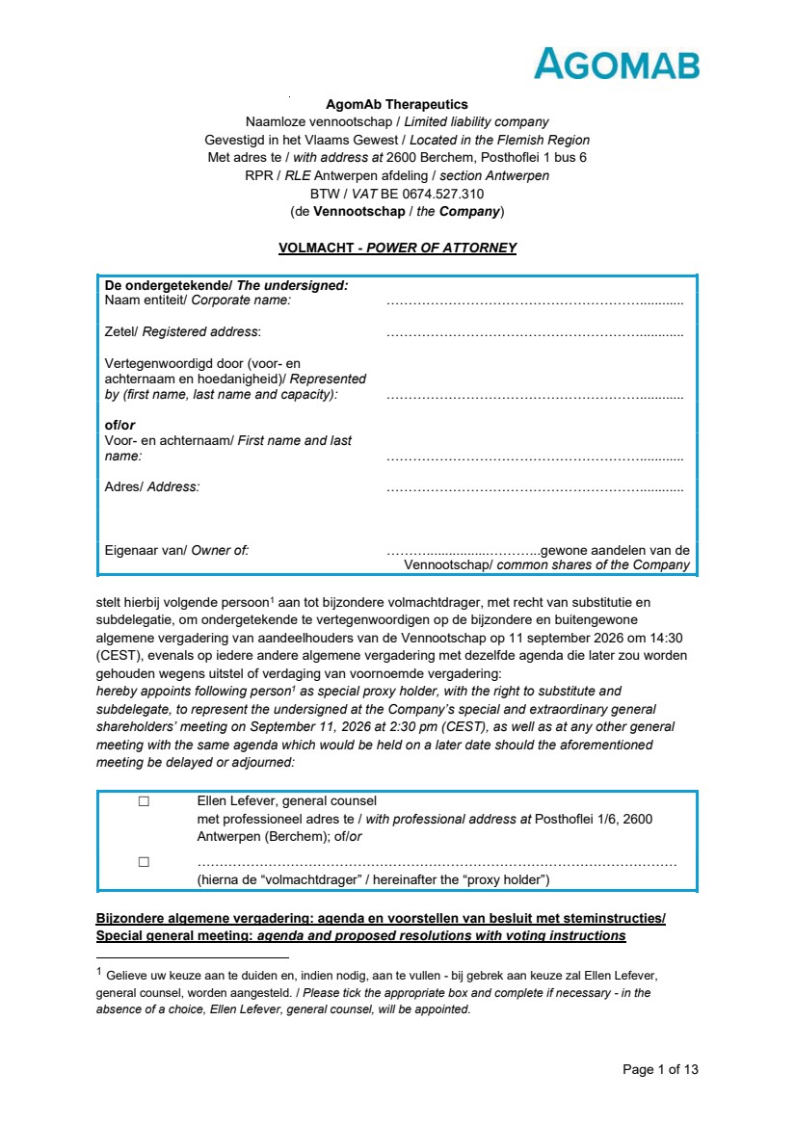 | Page 1 of 13 AgomAb Therapeutics Naamloze vennootschap / Limited liability company Gevestigd in het Vlaams Gewest / Located in the Flemish Region Met adres te / with address at 2600 Berchem, Posthoflei 1 bus 6 RPR / RLE Antwerpen afdeling / section Antwerpen BTW / VAT BE 0674.527.310 (de Vennootschap / the Company) VOLMACHT - POWER OF ATTORNEY De ondergetekende/ The undersigned: Naam entiteit/ Corporate name: …………………………………………………............ Zetel/ Registered address: …………………………………………………............ Vertegenwoordigd door (voor- en achternaam en hoedanigheid)/ Represented by (first name, last name and capacity): …………………………………………………............ of/or Voor- en achternaam/ First name and last name: …………………………………………………............ Adres/ Address: …………………………………………………............ Eigenaar van/ Owner of: ……….................………...gewone aandelen van de Vennootschap/ common shares of the Company stelt hierbij volgende persoon1 aan tot bijzondere volmachtdrager, met recht van substitutie en subdelegatie, om ondergetekende te vertegenwoordigen op de bijzondere en buitengewone algemene vergadering van aandeelhouders van de Vennootschap op 11 september 2026 om 14:30 (CEST), evenals op iedere andere algemene vergadering met dezelfde agenda die later zou worden gehouden wegens uitstel of verdaging van voornoemde vergadering: hereby appoints following person1 as special proxy holder, with the right to substitute and subdelegate, to represent the undersigned at the Company’s special and extraordinary general shareholders’ meeting on September 11, 2026 at 2:30 pm (CEST), as well as at any other general meeting with the same agenda which would be held on a later date should the aforementioned meeting be delayed or adjourned: ☐ Ellen Lefever, general counsel met professioneel adres te / with professional address at Posthoflei 1/6, 2600 Antwerpen (Berchem); of/or ☐ ……………………………………………………………………………………………… (hierna de “volmachtdrager” / hereinafter the “proxy holder”) Bijzondere algemene vergadering: agenda en voorstellen van besluit met steminstructies/ Special general meeting: agenda and proposed resolutions with voting instructions 1 Gelieve uw keuze aan te duiden en, indien nodig, aan te vullen - bij gebrek aan keuze zal Ellen Lefever, general counsel, worden aangesteld. / Please tick the appropriate box and complete if necessary - in the absence of a choice, Ellen Lefever, general counsel, will be appointed.
 | 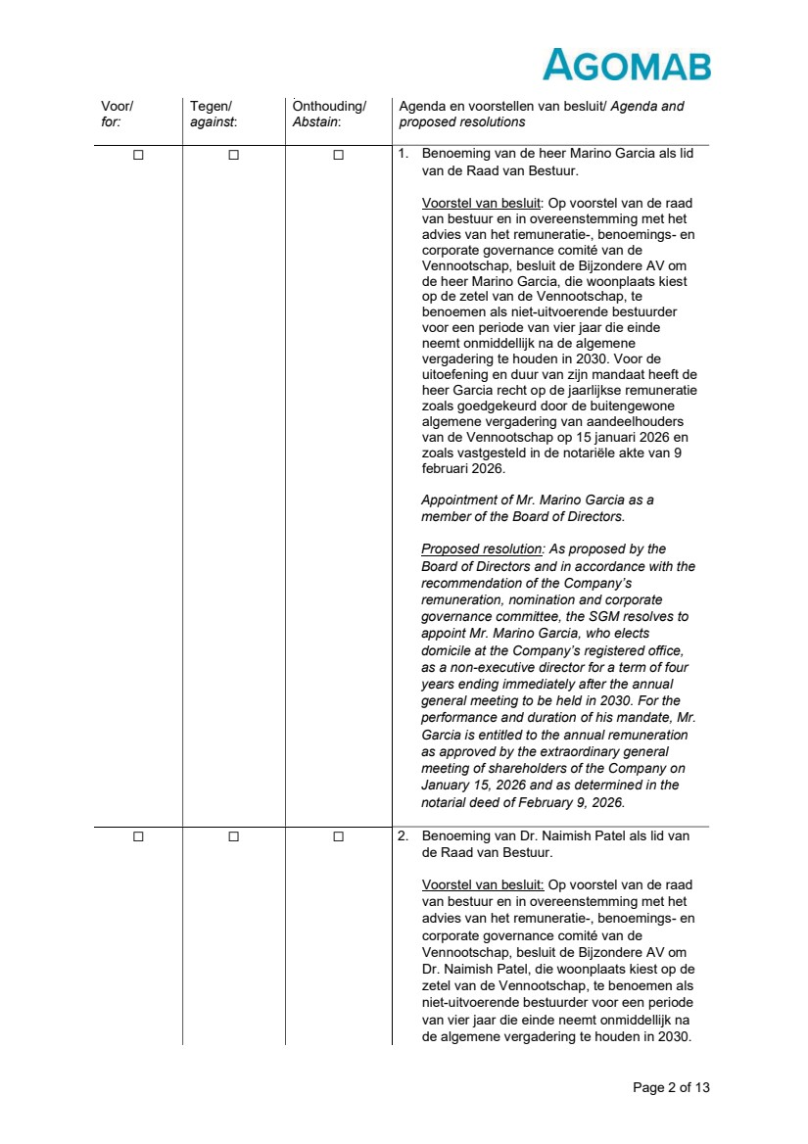 | Page 2 of 13 Voor/ for: Tegen/ against: Onthouding/ Abstain: Agenda en voorstellen van besluit/ Agenda and proposed resolutions ☐ ☐ ☐ 1. Benoeming van de heer Marino Garcia als lid van de Raad van Bestuur. Voorstel van besluit: Op voorstel van de raad van bestuur en in overeenstemming met het advies van het remuneratie-, benoemings- en corporate governance comité van de Vennootschap, besluit de Bijzondere AV om de heer Marino Garcia, die woonplaats kiest op de zetel van de Vennootschap, te benoemen als niet-uitvoerende bestuurder voor een periode van vier jaar die einde neemt onmiddellijk na de algemene vergadering te houden in 2030. Voor de uitoefening en duur van zijn mandaat heeft de heer Garcia recht op de jaarlijkse remuneratie zoals goedgekeurd door de buitengewone algemene vergadering van aandeelhouders van de Vennootschap op 15 januari 2026 en zoals vastgesteld in de notariële akte van 9 februari 2026. Appointment of Mr. Marino Garcia as a member of the Board of Directors. Proposed resolution: As proposed by the Board of Directors and in accordance with the recommendation of the Company’s remuneration, nomination and corporate governance committee, the SGM resolves to appoint Mr. Marino Garcia, who elects domicile at the Company’s registered office, as a non-executive director for a term of four years ending immediately after the annual general meeting to be held in 2030. For the performance and duration of his mandate, Mr. Garcia is entitled to the annual remuneration as approved by the extraordinary general meeting of shareholders of the Company on January 15, 2026 and as determined in the notarial deed of February 9, 2026. ☐ ☐ ☐ 2. Benoeming van Dr. Naimish Patel als lid van de Raad van Bestuur. Voorstel van besluit: Op voorstel van de raad van bestuur en in overeenstemming met het advies van het remuneratie-, benoemings- en corporate governance comité van de Vennootschap, besluit de Bijzondere AV om Dr. Naimish Patel, die woonplaats kiest op de zetel van de Vennootschap, te benoemen als niet-uitvoerende bestuurder voor een periode van vier jaar die einde neemt onmiddellijk na de algemene vergadering te houden in 2030.
 | 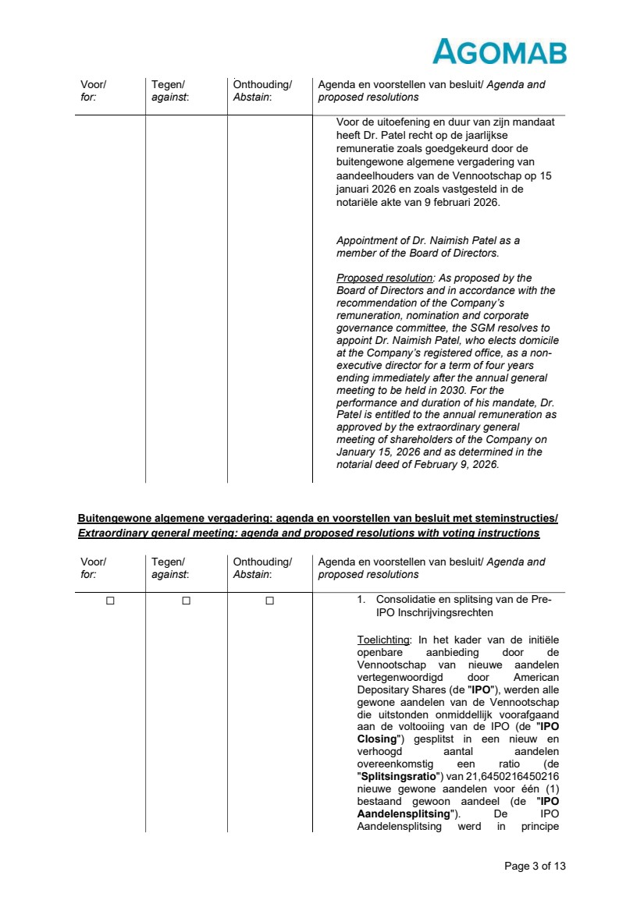 | Page 3 of 13 Buitengewone algemene vergadering: agenda en voorstellen van besluit met steminstructies/ Extraordinary general meeting: agenda and proposed resolutions with voting instructions Voor/ for: Tegen/ against: Onthouding/ Abstain: Agenda en voorstellen van besluit/ Agenda and proposed resolutions Voor de uitoefening en duur van zijn mandaat heeft Dr. Patel recht op de jaarlijkse remuneratie zoals goedgekeurd door de buitengewone algemene vergadering van aandeelhouders van de Vennootschap op 15 januari 2026 en zoals vastgesteld in de notariële akte van 9 februari 2026. Appointment of Dr. Naimish Patel as a member of the Board of Directors. Proposed resolution: As proposed by the Board of Directors and in accordance with the recommendation of the Company’s remuneration, nomination and corporate governance committee, the SGM resolves to appoint Dr. Naimish Patel, who elects domicile at the Company’s registered office, as a non-executive director for a term of four years ending immediately after the annual general meeting to be held in 2030. For the performance and duration of his mandate, Dr. Patel is entitled to the annual remuneration as approved by the extraordinary general meeting of shareholders of the Company on January 15, 2026 and as determined in the notarial deed of February 9, 2026. Voor/ for: Tegen/ against: Onthouding/ Abstain: Agenda en voorstellen van besluit/ Agenda and proposed resolutions ☐ ☐ ☐ 1. Consolidatie en splitsing van de Pre-IPO Inschrijvingsrechten Toelichting: In het kader van de initiële openbare aanbieding door de Vennootschap van nieuwe aandelen vertegenwoordigd door American Depositary Shares (de "IPO"), werden alle gewone aandelen van de Vennootschap die uitstonden onmiddellijk voorafgaand aan de voltooiing van de IPO (de "IPO Closing") gesplitst in een nieuw en verhoogd aantal aandelen overeenkomstig een ratio (de "Splitsingsratio") van 21,6450216450216 nieuwe gewone aandelen voor één (1) bestaand gewoon aandeel (de "IPO Aandelensplitsing"). De IPO Aandelensplitsing werd in principe
 | 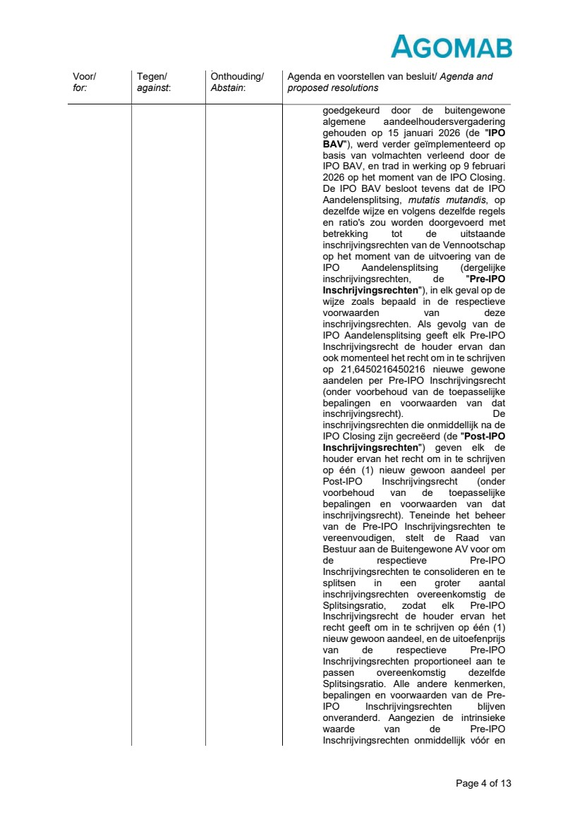 | Page 4 of 13 Voor/ for: Tegen/ against: Onthouding/ Abstain: Agenda en voorstellen van besluit/ Agenda and proposed resolutions goedgekeurd door de buitengewone algemene aandeelhoudersvergadering gehouden op 15 januari 2026 (de "IPO BAV"), werd verder geïmplementeerd op basis van volmachten verleend door de IPO BAV, en trad in werking op 9 februari 2026 op het moment van de IPO Closing. De IPO BAV besloot tevens dat de IPO Aandelensplitsing, mutatis mutandis, op dezelfde wijze en volgens dezelfde regels en ratio's zou worden doorgevoerd met betrekking tot de uitstaande inschrijvingsrechten van de Vennootschap op het moment van de uitvoering van de IPO Aandelensplitsing (dergelijke inschrijvingsrechten, de "Pre-IPO Inschrijvingsrechten"), in elk geval op de wijze zoals bepaald in de respectieve voorwaarden van deze inschrijvingsrechten. Als gevolg van de IPO Aandelensplitsing geeft elk Pre-IPO Inschrijvingsrecht de houder ervan dan ook momenteel het recht om in te schrijven op 21,6450216450216 nieuwe gewone aandelen per Pre-IPO Inschrijvingsrecht (onder voorbehoud van de toepasselijke bepalingen en voorwaarden van dat inschrijvingsrecht). De inschrijvingsrechten die onmiddellijk na de IPO Closing zijn gecreëerd (de "Post-IPO Inschrijvingsrechten") geven elk de houder ervan het recht om in te schrijven op één (1) nieuw gewoon aandeel per Post-IPO Inschrijvingsrecht (onder voorbehoud van de toepasselijke bepalingen en voorwaarden van dat inschrijvingsrecht). Teneinde het beheer van de Pre-IPO Inschrijvingsrechten te vereenvoudigen, stelt de Raad van Bestuur aan de Buitengewone AV voor om de respectieve Pre-IPO Inschrijvingsrechten te consolideren en te splitsen in een groter aantal inschrijvingsrechten overeenkomstig de Splitsingsratio, zodat elk Pre-IPO Inschrijvingsrecht de houder ervan het recht geeft om in te schrijven op één (1) nieuw gewoon aandeel, en de uitoefenprijs van de respectieve Pre-IPO Inschrijvingsrechten proportioneel aan te passen overeenkomstig dezelfde Splitsingsratio. Alle andere kenmerken, bepalingen en voorwaarden van de Pre-IPO Inschrijvingsrechten blijven onveranderd. Aangezien de intrinsieke waarde van de Pre-IPO Inschrijvingsrechten onmiddellijk vóór en
 | 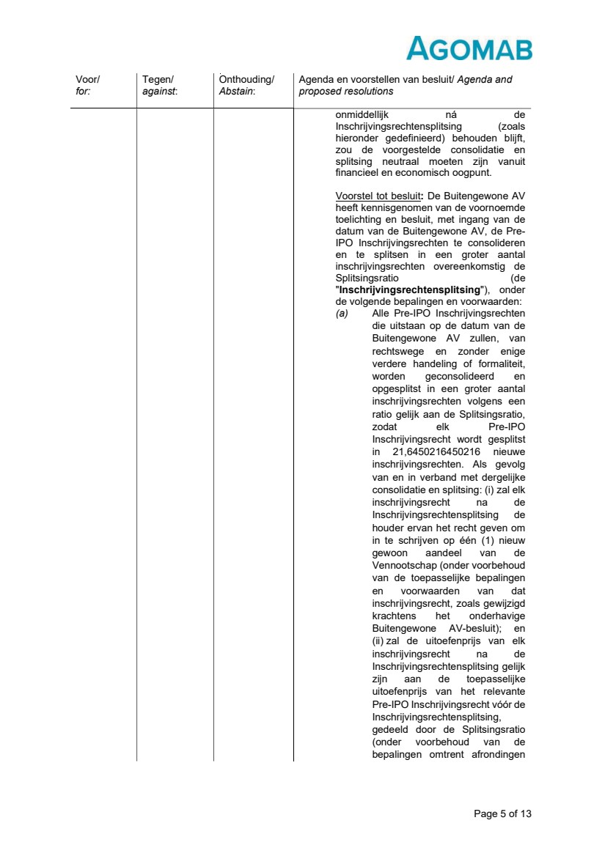 | Page 5 of 13 Voor/ for: Tegen/ against: Onthouding/ Abstain: Agenda en voorstellen van besluit/ Agenda and proposed resolutions onmiddellijk ná de Inschrijvingsrechtensplitsing (zoals hieronder gedefinieerd) behouden blijft, zou de voorgestelde consolidatie en splitsing neutraal moeten zijn vanuit financieel en economisch oogpunt. Voorstel tot besluit: De Buitengewone AV heeft kennisgenomen van de voornoemde toelichting en besluit, met ingang van de datum van de Buitengewone AV, de Pre-IPO Inschrijvingsrechten te consolideren en te splitsen in een groter aantal inschrijvingsrechten overeenkomstig de Splitsingsratio (de "Inschrijvingsrechtensplitsing"), onder de volgende bepalingen en voorwaarden: (a) Alle Pre-IPO Inschrijvingsrechten die uitstaan op de datum van de Buitengewone AV zullen, van rechtswege en zonder enige verdere handeling of formaliteit, worden geconsolideerd en opgesplitst in een groter aantal inschrijvingsrechten volgens een ratio gelijk aan de Splitsingsratio, zodat elk Pre-IPO Inschrijvingsrecht wordt gesplitst in 21,6450216450216 nieuwe inschrijvingsrechten. Als gevolg van en in verband met dergelijke consolidatie en splitsing: (i) zal elk inschrijvingsrecht na de Inschrijvingsrechtensplitsing de houder ervan het recht geven om in te schrijven op één (1) nieuw gewoon aandeel van de Vennootschap (onder voorbehoud van de toepasselijke bepalingen en voorwaarden van dat inschrijvingsrecht, zoals gewijzigd krachtens het onderhavige Buitengewone AV-besluit); en (ii) zal de uitoefenprijs van elk inschrijvingsrecht na de Inschrijvingsrechtensplitsing gelijk zijn aan de toepasselijke uitoefenprijs van het relevante Pre-IPO Inschrijvingsrecht vóór de Inschrijvingsrechtensplitsing, gedeeld door de Splitsingsratio (onder voorbehoud van de bepalingen omtrent afrondingen
 | 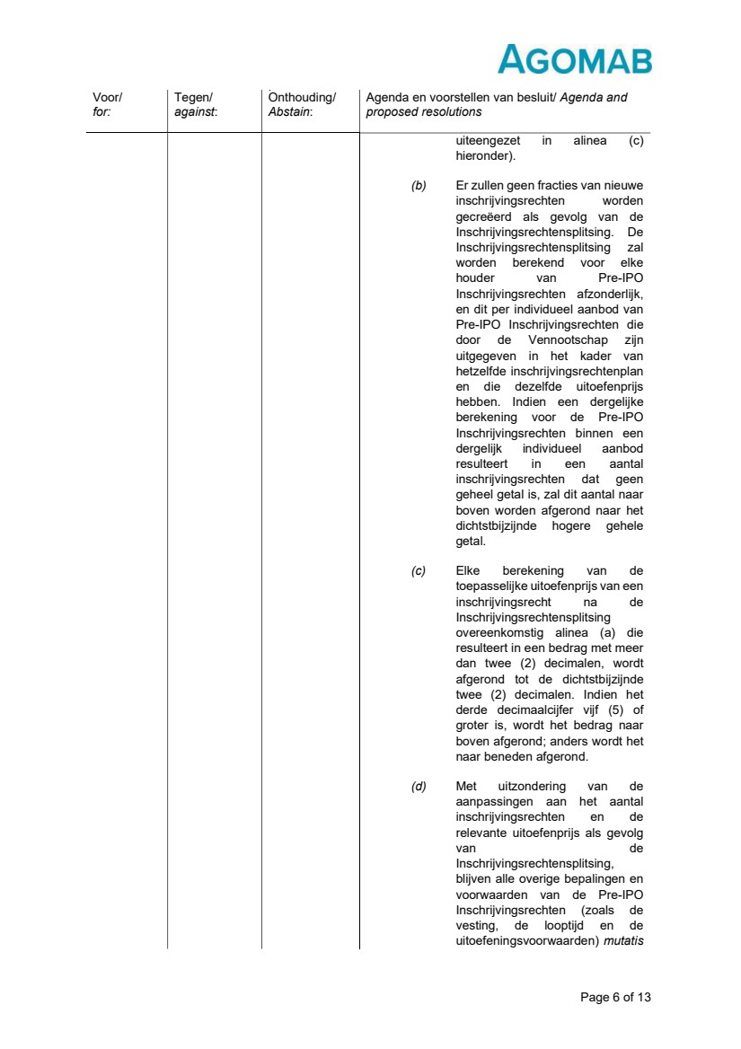 | Page 6 of 13 Voor/ for: Tegen/ against: Onthouding/ Abstain: Agenda en voorstellen van besluit/ Agenda and proposed resolutions uiteengezet in alinea (c) hieronder). (b) Er zullen geen fracties van nieuwe inschrijvingsrechten worden gecreëerd als gevolg van de Inschrijvingsrechtensplitsing. De Inschrijvingsrechtensplitsing zal worden berekend voor elke houder van Pre-IPO Inschrijvingsrechten afzonderlijk, en dit per individueel aanbod van Pre-IPO Inschrijvingsrechten die door de Vennootschap zijn uitgegeven in het kader van hetzelfde inschrijvingsrechtenplan en die dezelfde uitoefenprijs hebben. Indien een dergelijke berekening voor de Pre-IPO Inschrijvingsrechten binnen een dergelijk individueel aanbod resulteert in een aantal inschrijvingsrechten dat geen geheel getal is, zal dit aantal naar boven worden afgerond naar het dichtstbijzijnde hogere gehele getal. (c) Elke berekening van de toepasselijke uitoefenprijs van een inschrijvingsrecht na de Inschrijvingsrechtensplitsing overeenkomstig alinea (a) die resulteert in een bedrag met meer dan twee (2) decimalen, wordt afgerond tot de dichtstbijzijnde twee (2) decimalen. Indien het derde decimaalcijfer vijf (5) of groter is, wordt het bedrag naar boven afgerond; anders wordt het naar beneden afgerond. (d) Met uitzondering van de aanpassingen aan het aantal inschrijvingsrechten en de relevante uitoefenprijs als gevolg van de Inschrijvingsrechtensplitsing, blijven alle overige bepalingen en voorwaarden van de Pre-IPO Inschrijvingsrechten (zoals de vesting, de looptijd en de uitoefeningsvoorwaarden) mutatis
 | 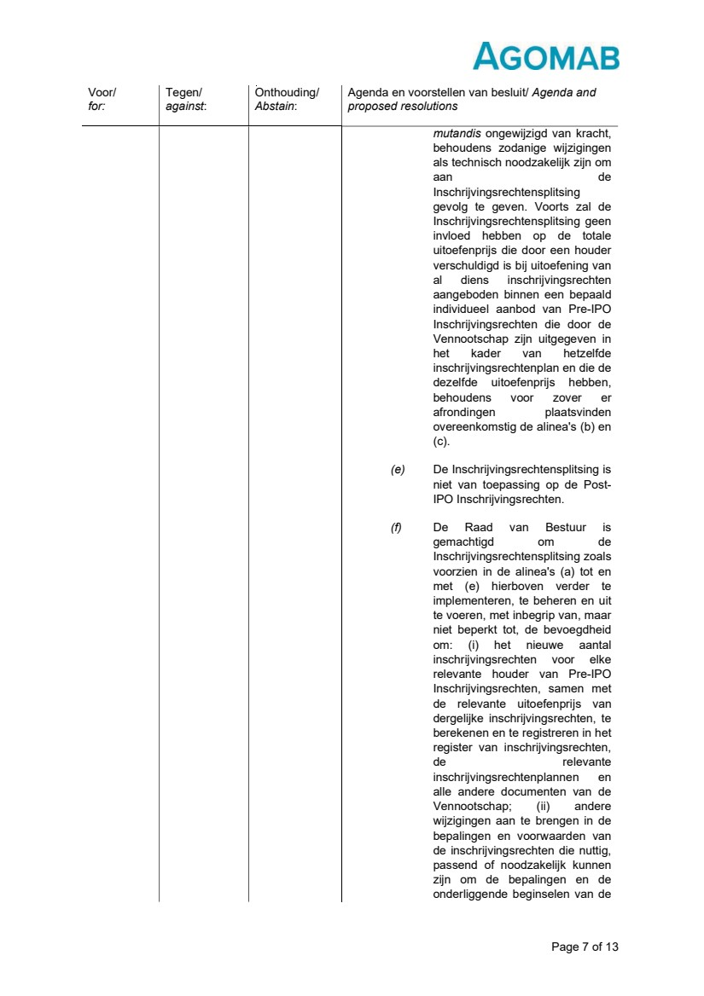 | Page 7 of 13 Voor/ for: Tegen/ against: Onthouding/ Abstain: Agenda en voorstellen van besluit/ Agenda and proposed resolutions mutandis ongewijzigd van kracht, behoudens zodanige wijzigingen als technisch noodzakelijk zijn om aan de Inschrijvingsrechtensplitsing gevolg te geven. Voorts zal de Inschrijvingsrechtensplitsing geen invloed hebben op de totale uitoefenprijs die door een houder verschuldigd is bij uitoefening van al diens inschrijvingsrechten aangeboden binnen een bepaald individueel aanbod van Pre-IPO Inschrijvingsrechten die door de Vennootschap zijn uitgegeven in het kader van hetzelfde inschrijvingsrechtenplan en die de dezelfde uitoefenprijs hebben, behoudens voor zover er afrondingen plaatsvinden overeenkomstig de alinea's (b) en (c). (e) De Inschrijvingsrechtensplitsing is niet van toepassing op de Post-IPO Inschrijvingsrechten. (f) De Raad van Bestuur is gemachtigd om de Inschrijvingsrechtensplitsing zoals voorzien in de alinea's (a) tot en met (e) hierboven verder te implementeren, te beheren en uit te voeren, met inbegrip van, maar niet beperkt tot, de bevoegdheid om: (i) het nieuwe aantal inschrijvingsrechten voor elke relevante houder van Pre-IPO Inschrijvingsrechten, samen met de relevante uitoefenprijs van dergelijke inschrijvingsrechten, te berekenen en te registreren in het register van inschrijvingsrechten, de relevante inschrijvingsrechtenplannen en alle andere documenten van de Vennootschap; (ii) andere wijzigingen aan te brengen in de bepalingen en voorwaarden van de inschrijvingsrechten die nuttig, passend of noodzakelijk kunnen zijn om de bepalingen en de onderliggende beginselen van de
 | 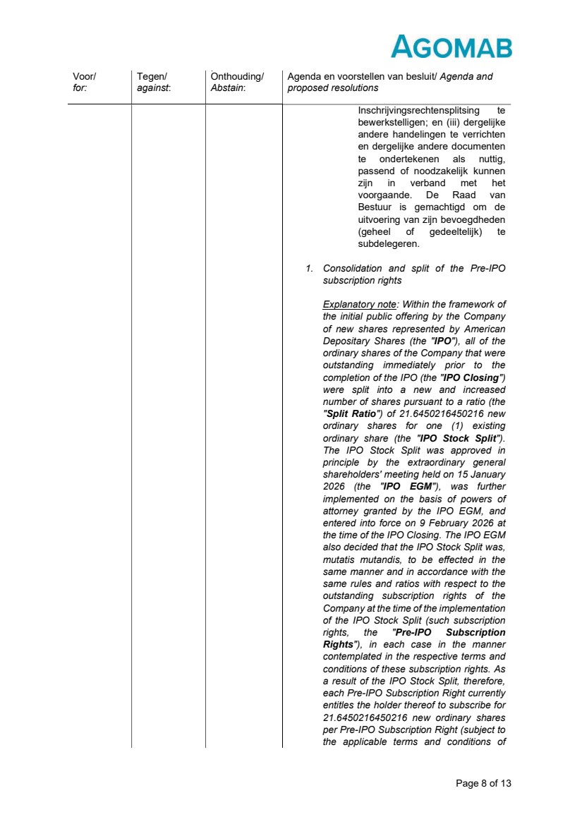 | Page 8 of 13 Voor/ for: Tegen/ against: Onthouding/ Abstain: Agenda en voorstellen van besluit/ Agenda and proposed resolutions Inschrijvingsrechtensplitsing te bewerkstelligen; en (iii) dergelijke andere handelingen te verrichten en dergelijke andere documenten te ondertekenen als nuttig, passend of noodzakelijk kunnen zijn in verband met het voorgaande. De Raad van Bestuur is gemachtigd om de uitvoering van zijn bevoegdheden (geheel of gedeeltelijk) te subdelegeren. 1. Consolidation and split of the Pre-IPO subscription rights Explanatory note: Within the framework of the initial public offering by the Company of new shares represented by American Depositary Shares (the "IPO"), all of the ordinary shares of the Company that were outstanding immediately prior to the completion of the IPO (the "IPO Closing") were split into a new and increased number of shares pursuant to a ratio (the "Split Ratio") of 21.6450216450216 new ordinary shares for one (1) existing ordinary share (the "IPO Stock Split"). The IPO Stock Split was approved in principle by the extraordinary general shareholders' meeting held on 15 January 2026 (the "IPO EGM"), was further implemented on the basis of powers of attorney granted by the IPO EGM, and entered into force on 9 February 2026 at the time of the IPO Closing. The IPO EGM also decided that the IPO Stock Split was, mutatis mutandis, to be effected in the same manner and in accordance with the same rules and ratios with respect to the outstanding subscription rights of the Company at the time of the implementation of the IPO Stock Split (such subscription rights, the "Pre-IPO Subscription Rights"), in each case in the manner contemplated in the respective terms and conditions of these subscription rights. As a result of the IPO Stock Split, therefore, each Pre-IPO Subscription Right currently entitles the holder thereof to subscribe for 21.6450216450216 new ordinary shares per Pre-IPO Subscription Right (subject to the applicable terms and conditions of
 | 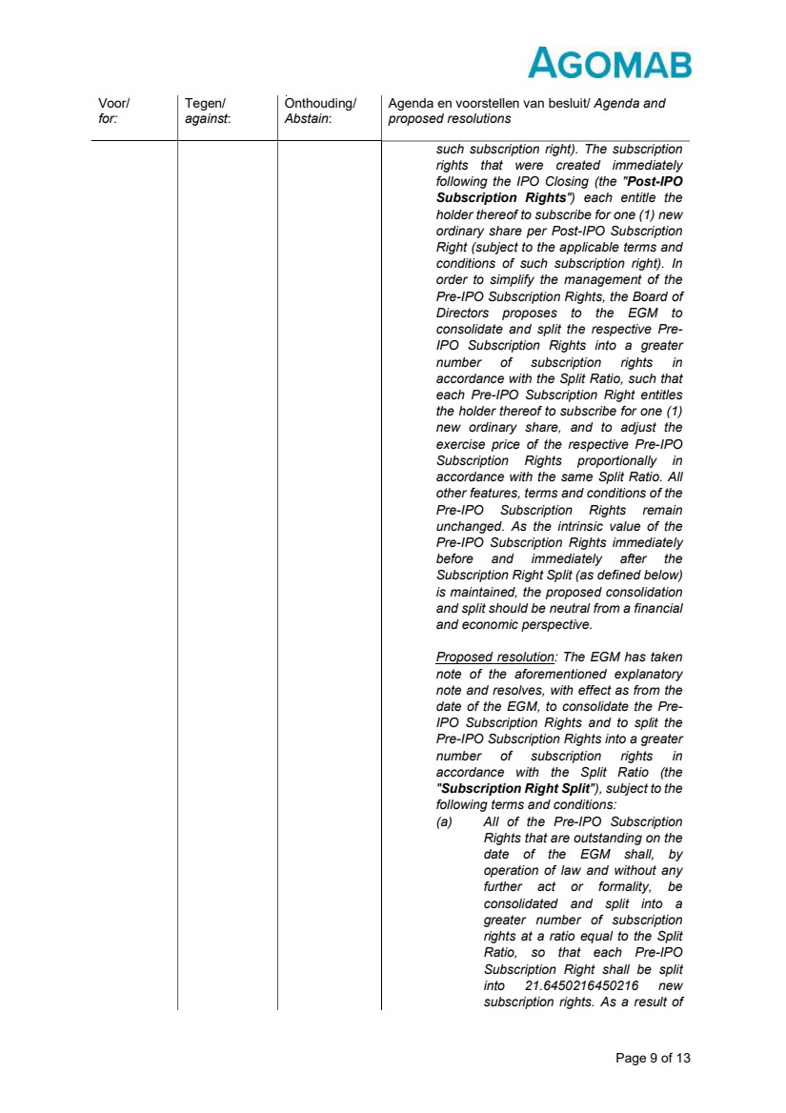 | Page 9 of 13 Voor/ for: Tegen/ against: Onthouding/ Abstain: Agenda en voorstellen van besluit/ Agenda and proposed resolutions such subscription right). The subscription rights that were created immediately following the IPO Closing (the "Post-IPO Subscription Rights") each entitle the holder thereof to subscribe for one (1) new ordinary share per Post-IPO Subscription Right (subject to the applicable terms and conditions of such subscription right). In order to simplify the management of the Pre-IPO Subscription Rights, the Board of Directors proposes to the EGM to consolidate and split the respective Pre-IPO Subscription Rights into a greater number of subscription rights in accordance with the Split Ratio, such that each Pre-IPO Subscription Right entitles the holder thereof to subscribe for one (1) new ordinary share, and to adjust the exercise price of the respective Pre-IPO Subscription Rights proportionally in accordance with the same Split Ratio. All other features, terms and conditions of the Pre-IPO Subscription Rights remain unchanged. As the intrinsic value of the Pre-IPO Subscription Rights immediately before and immediately after the Subscription Right Split (as defined below) is maintained, the proposed consolidation and split should be neutral from a financial and economic perspective. Proposed resolution: The EGM has taken note of the aforementioned explanatory note and resolves, with effect as from the date of the EGM, to consolidate the Pre-IPO Subscription Rights and to split the Pre-IPO Subscription Rights into a greater number of subscription rights in accordance with the Split Ratio (the "Subscription Right Split"), subject to the following terms and conditions: (a) All of the Pre-IPO Subscription Rights that are outstanding on the date of the EGM shall, by operation of law and without any further act or formality, be consolidated and split into a greater number of subscription rights at a ratio equal to the Split Ratio, so that each Pre-IPO Subscription Right shall be split into 21.6450216450216 new subscription rights. As a result of
 | 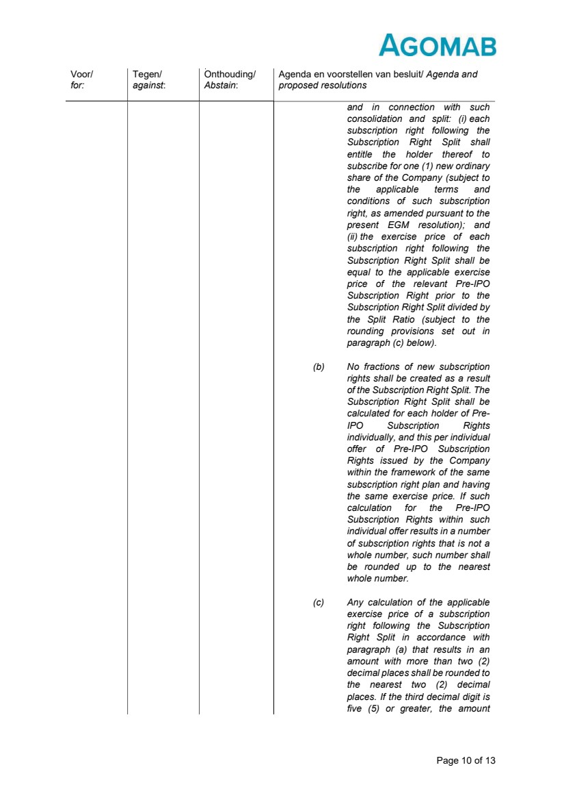 | Page 10 of 13 Voor/ for: Tegen/ against: Onthouding/ Abstain: Agenda en voorstellen van besluit/ Agenda and proposed resolutions and in connection with such consolidation and split: (i) each subscription right following the Subscription Right Split shall entitle the holder thereof to subscribe for one (1) new ordinary share of the Company (subject to the applicable terms and conditions of such subscription right, as amended pursuant to the present EGM resolution); and (ii) the exercise price of each subscription right following the Subscription Right Split shall be equal to the applicable exercise price of the relevant Pre-IPO Subscription Right prior to the Subscription Right Split divided by the Split Ratio (subject to the rounding provisions set out in paragraph (c) below). (b) No fractions of new subscription rights shall be created as a result of the Subscription Right Split. The Subscription Right Split shall be calculated for each holder of Pre-IPO Subscription Rights individually, and this per individual offer of Pre-IPO Subscription Rights issued by the Company within the framework of the same subscription right plan and having the same exercise price. If such calculation for the Pre-IPO Subscription Rights within such individual offer results in a number of subscription rights that is not a whole number, such number shall be rounded up to the nearest whole number. (c) Any calculation of the applicable exercise price of a subscription right following the Subscription Right Split in accordance with paragraph (a) that results in an amount with more than two (2) decimal places shall be rounded to the nearest two (2) decimal places. If the third decimal digit is five (5) or greater, the amount
 | 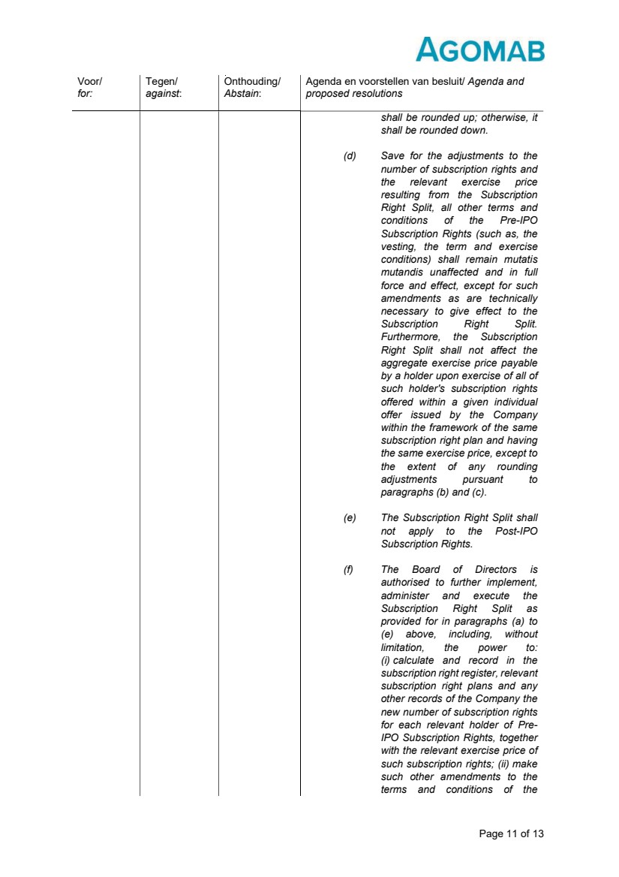 | Page 11 of 13 Voor/ for: Tegen/ against: Onthouding/ Abstain: Agenda en voorstellen van besluit/ Agenda and proposed resolutions shall be rounded up; otherwise, it shall be rounded down. (d) Save for the adjustments to the number of subscription rights and the relevant exercise price resulting from the Subscription Right Split, all other terms and conditions of the Pre-IPO Subscription Rights (such as, the vesting, the term and exercise conditions) shall remain mutatis mutandis unaffected and in full force and effect, except for such amendments as are technically necessary to give effect to the Subscription Right Split. Furthermore, the Subscription Right Split shall not affect the aggregate exercise price payable by a holder upon exercise of all of such holder's subscription rights offered within a given individual offer issued by the Company within the framework of the same subscription right plan and having the same exercise price, except to the extent of any rounding adjustments pursuant to paragraphs (b) and (c). (e) The Subscription Right Split shall not apply to the Post-IPO Subscription Rights. (f) The Board of Directors is authorised to further implement, administer and execute the Subscription Right Split as provided for in paragraphs (a) to (e) above, including, without limitation, the power to: (i) calculate and record in the subscription right register, relevant subscription right plans and any other records of the Company the new number of subscription rights for each relevant holder of Pre-IPO Subscription Rights, together with the relevant exercise price of such subscription rights; (ii) make such other amendments to the terms and conditions of the
 | 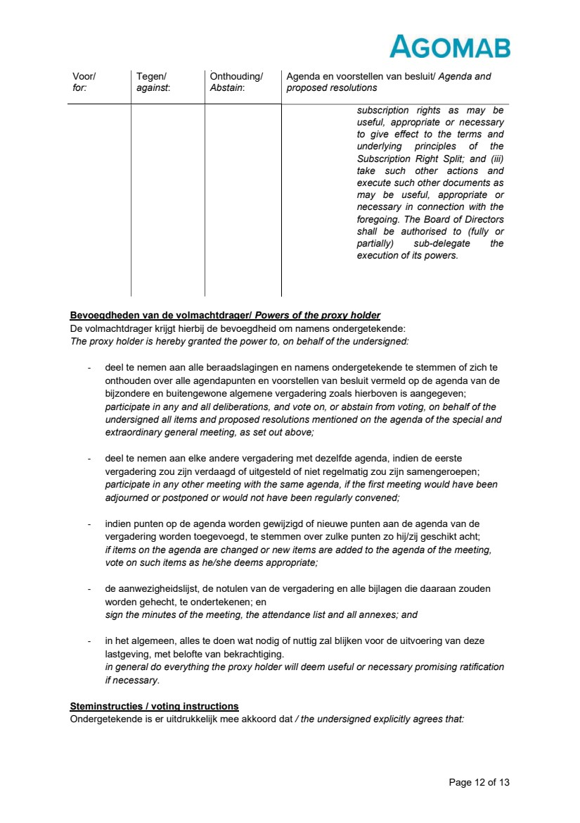 | Page 12 of 13 Bevoegdheden van de volmachtdrager/ Powers of the proxy holder De volmachtdrager krijgt hierbij de bevoegdheid om namens ondergetekende: The proxy holder is hereby granted the power to, on behalf of the undersigned: - deel te nemen aan alle beraadslagingen en namens ondergetekende te stemmen of zich te onthouden over alle agendapunten en voorstellen van besluit vermeld op de agenda van de bijzondere en buitengewone algemene vergadering zoals hierboven is aangegeven; participate in any and all deliberations, and vote on, or abstain from voting, on behalf of the undersigned all items and proposed resolutions mentioned on the agenda of the special and extraordinary general meeting, as set out above; - deel te nemen aan elke andere vergadering met dezelfde agenda, indien de eerste vergadering zou zijn verdaagd of uitgesteld of niet regelmatig zou zijn samengeroepen; participate in any other meeting with the same agenda, if the first meeting would have been adjourned or postponed or would not have been regularly convened; - indien punten op de agenda worden gewijzigd of nieuwe punten aan de agenda van de vergadering worden toegevoegd, te stemmen over zulke punten zo hij/zij geschikt acht; if items on the agenda are changed or new items are added to the agenda of the meeting, vote on such items as he/she deems appropriate; - de aanwezigheidslijst, de notulen van de vergadering en alle bijlagen die daaraan zouden worden gehecht, te ondertekenen; en sign the minutes of the meeting, the attendance list and all annexes; and - in het algemeen, alles te doen wat nodig of nuttig zal blijken voor de uitvoering van deze lastgeving, met belofte van bekrachtiging. in general do everything the proxy holder will deem useful or necessary promising ratification if necessary. Steminstructies / voting instructions Ondergetekende is er uitdrukkelijk mee akkoord dat / the undersigned explicitly agrees that: Voor/ for: Tegen/ against: Onthouding/ Abstain: Agenda en voorstellen van besluit/ Agenda and proposed resolutions subscription rights as may be useful, appropriate or necessary to give effect to the terms and underlying principles of the Subscription Right Split; and (iii) take such other actions and execute such other documents as may be useful, appropriate or necessary in connection with the foregoing. The Board of Directors shall be authorised to (fully or partially) sub-delegate the execution of its powers.
 | 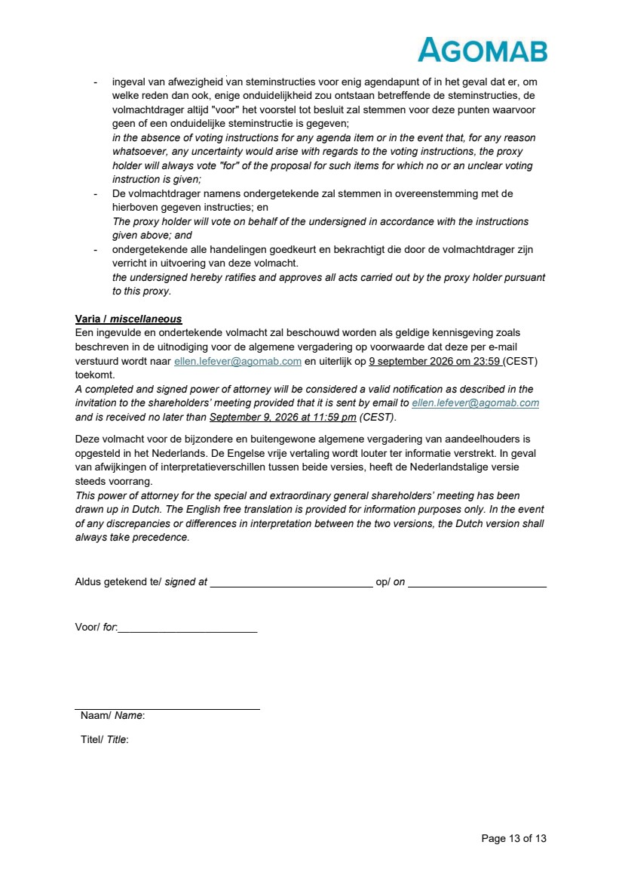 | Page 13 of 13 - ingeval van afwezigheid van steminstructies voor enig agendapunt of in het geval dat er, om welke reden dan ook, enige onduidelijkheid zou ontstaan betreffende de steminstructies, de volmachtdrager altijd "voor" het voorstel tot besluit zal stemmen voor deze punten waarvoor geen of een onduidelijke steminstructie is gegeven; in the absence of voting instructions for any agenda item or in the event that, for any reason whatsoever, any uncertainty would arise with regards to the voting instructions, the proxy holder will always vote "for" of the proposal for such items for which no or an unclear voting instruction is given; - De volmachtdrager namens ondergetekende zal stemmen in overeenstemming met de hierboven gegeven instructies; en The proxy holder will vote on behalf of the undersigned in accordance with the instructions given above; and - ondergetekende alle handelingen goedkeurt en bekrachtigt die door de volmachtdrager zijn verricht in uitvoering van deze volmacht. the undersigned hereby ratifies and approves all acts carried out by the proxy holder pursuant to this proxy. Varia / miscellaneous Een ingevulde en ondertekende volmacht zal beschouwd worden als geldige kennisgeving zoals beschreven in de uitnodiging voor de algemene vergadering op voorwaarde dat deze per e-mail verstuurd wordt naar ellen.lefever@agomab.com en uiterlijk op 9 september 2026 om 23:59 (CEST) toekomt. A completed and signed power of attorney will be considered a valid notification as described in the invitation to the shareholders’ meeting provided that it is sent by email to ellen.lefever@agomab.com and is received no later than September 9, 2026 at 11:59 pm (CEST). Deze volmacht voor de bijzondere en buitengewone algemene vergadering van aandeelhouders is opgesteld in het Nederlands. De Engelse vrije vertaling wordt louter ter informatie verstrekt. In geval van afwijkingen of interpretatieverschillen tussen beide versies, heeft de Nederlandstalige versie steeds voorrang. This power of attorney for the special and extraordinary general shareholders’ meeting has been drawn up in Dutch. The English free translation is provided for information purposes only. In the event of any discrepancies or differences in interpretation between the two versions, the Dutch version shall always take precedence. Aldus getekend te/ signed at op/ on Voor/ for:________________________ Naam/ Name: Titel/ Title:
Exhibit 99.4

 | 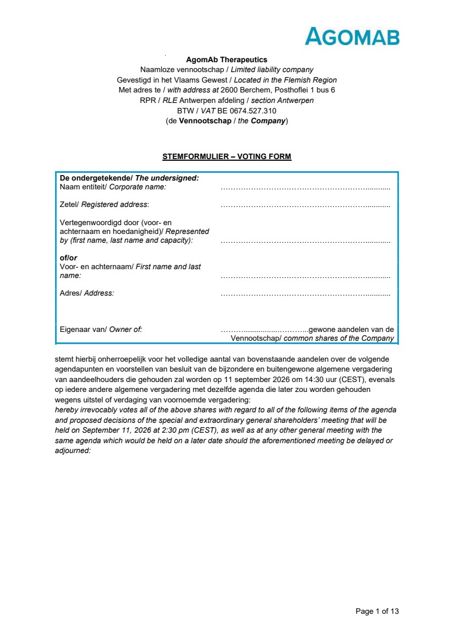 | Page 1 of 13 AgomAb Therapeutics Naamloze vennootschap / Limited liability company Gevestigd in het Vlaams Gewest / Located in the Flemish Region Met adres te / with address at 2600 Berchem, Posthoflei 1 bus 6 RPR / RLE Antwerpen afdeling / section Antwerpen BTW / VAT BE 0674.527.310 (de Vennootschap / the Company) STEMFORMULIER – VOTING FORM De ondergetekende/ The undersigned: Naam entiteit/ Corporate name: …………………………………………………............ Zetel/ Registered address: …………………………………………………............ Vertegenwoordigd door (voor- en achternaam en hoedanigheid)/ Represented by (first name, last name and capacity): …………………………………………………............ of/or Voor- en achternaam/ First name and last name: …………………………………………………............ Adres/ Address: …………………………………………………............ Eigenaar van/ Owner of: ……….................………...gewone aandelen van de Vennootschap/ common shares of the Company stemt hierbij onherroepelijk voor het volledige aantal van bovenstaande aandelen over de volgende agendapunten en voorstellen van besluit van de bijzondere en buitengewone algemene vergadering van aandeelhouders die gehouden zal worden op 11 september 2026 om 14:30 uur (CEST), evenals op iedere andere algemene vergadering met dezelfde agenda die later zou worden gehouden wegens uitstel of verdaging van voornoemde vergadering: hereby irrevocably votes all of the above shares with regard to all of the following items of the agenda and proposed decisions of the special and extraordinary general shareholders’ meeting that will be held on September 11, 2026 at 2:30 pm (CEST), as well as at any other general meeting with the same agenda which would be held on a later date should the aforementioned meeting be delayed or adjourned:
 | 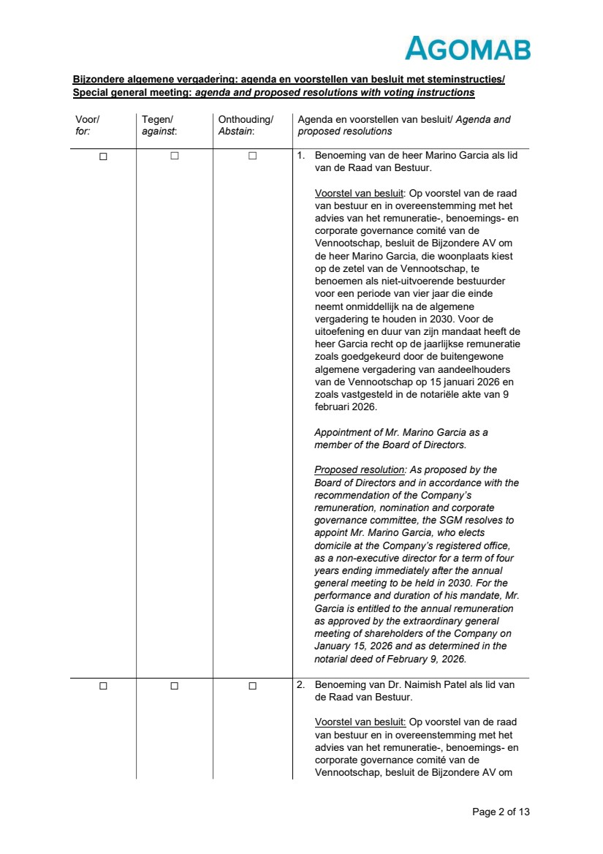 | Page 2 of 13 Bijzondere algemene vergadering: agenda en voorstellen van besluit met steminstructies/ Special general meeting: agenda and proposed resolutions with voting instructions Voor/ for: Tegen/ against: Onthouding/ Abstain: Agenda en voorstellen van besluit/ Agenda and proposed resolutions ☐ ☐ ☐ 1. Benoeming van de heer Marino Garcia als lid van de Raad van Bestuur. Voorstel van besluit: Op voorstel van de raad van bestuur en in overeenstemming met het advies van het remuneratie-, benoemings- en corporate governance comité van de Vennootschap, besluit de Bijzondere AV om de heer Marino Garcia, die woonplaats kiest op de zetel van de Vennootschap, te benoemen als niet-uitvoerende bestuurder voor een periode van vier jaar die einde neemt onmiddellijk na de algemene vergadering te houden in 2030. Voor de uitoefening en duur van zijn mandaat heeft de heer Garcia recht op de jaarlijkse remuneratie zoals goedgekeurd door de buitengewone algemene vergadering van aandeelhouders van de Vennootschap op 15 januari 2026 en zoals vastgesteld in de notariële akte van 9 februari 2026. Appointment of Mr. Marino Garcia as a member of the Board of Directors. Proposed resolution: As proposed by the Board of Directors and in accordance with the recommendation of the Company’s remuneration, nomination and corporate governance committee, the SGM resolves to appoint Mr. Marino Garcia, who elects domicile at the Company’s registered office, as a non-executive director for a term of four years ending immediately after the annual general meeting to be held in 2030. For the performance and duration of his mandate, Mr. Garcia is entitled to the annual remuneration as approved by the extraordinary general meeting of shareholders of the Company on January 15, 2026 and as determined in the notarial deed of February 9, 2026. ☐ ☐ ☐ 2. Benoeming van Dr. Naimish Patel als lid van de Raad van Bestuur. Voorstel van besluit: Op voorstel van de raad van bestuur en in overeenstemming met het advies van het remuneratie-, benoemings- en corporate governance comité van de Vennootschap, besluit de Bijzondere AV om
 | 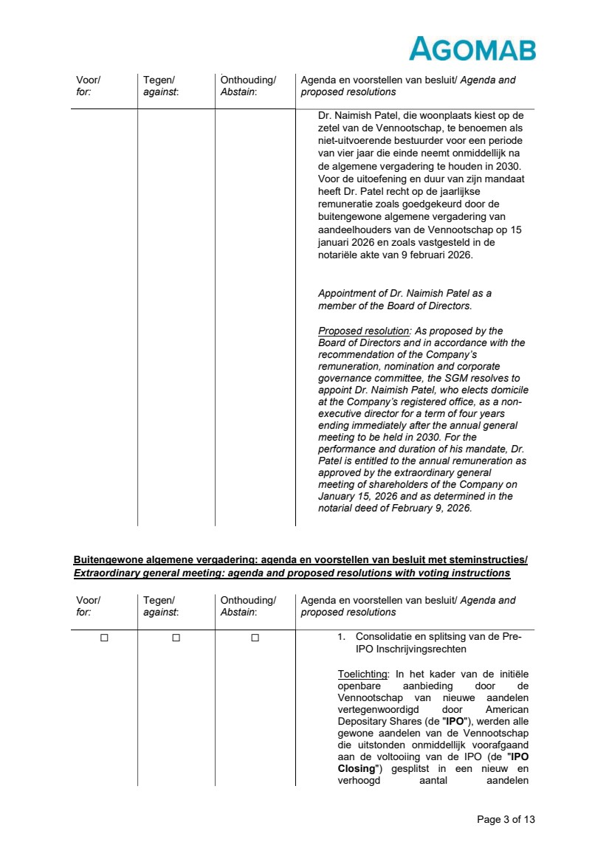 | Page 3 of 13 Buitengewone algemene vergadering: agenda en voorstellen van besluit met steminstructies/ Extraordinary general meeting: agenda and proposed resolutions with voting instructions Voor/ for: Tegen/ against: Onthouding/ Abstain: Agenda en voorstellen van besluit/ Agenda and proposed resolutions Dr. Naimish Patel, die woonplaats kiest op de zetel van de Vennootschap, te benoemen als niet-uitvoerende bestuurder voor een periode van vier jaar die einde neemt onmiddellijk na de algemene vergadering te houden in 2030. Voor de uitoefening en duur van zijn mandaat heeft Dr. Patel recht op de jaarlijkse remuneratie zoals goedgekeurd door de buitengewone algemene vergadering van aandeelhouders van de Vennootschap op 15 januari 2026 en zoals vastgesteld in de notariële akte van 9 februari 2026. Appointment of Dr. Naimish Patel as a member of the Board of Directors. Proposed resolution: As proposed by the Board of Directors and in accordance with the recommendation of the Company’s remuneration, nomination and corporate governance committee, the SGM resolves to appoint Dr. Naimish Patel, who elects domicile at the Company’s registered office, as a non-executive director for a term of four years ending immediately after the annual general meeting to be held in 2030. For the performance and duration of his mandate, Dr. Patel is entitled to the annual remuneration as approved by the extraordinary general meeting of shareholders of the Company on January 15, 2026 and as determined in the notarial deed of February 9, 2026. Voor/ for: Tegen/ against: Onthouding/ Abstain: Agenda en voorstellen van besluit/ Agenda and proposed resolutions ☐ ☐ ☐ 1. Consolidatie en splitsing van de Pre-IPO Inschrijvingsrechten Toelichting: In het kader van de initiële openbare aanbieding door de Vennootschap van nieuwe aandelen vertegenwoordigd door American Depositary Shares (de "IPO"), werden alle gewone aandelen van de Vennootschap die uitstonden onmiddellijk voorafgaand aan de voltooiing van de IPO (de "IPO Closing") gesplitst in een nieuw en verhoogd aantal aandelen
 | 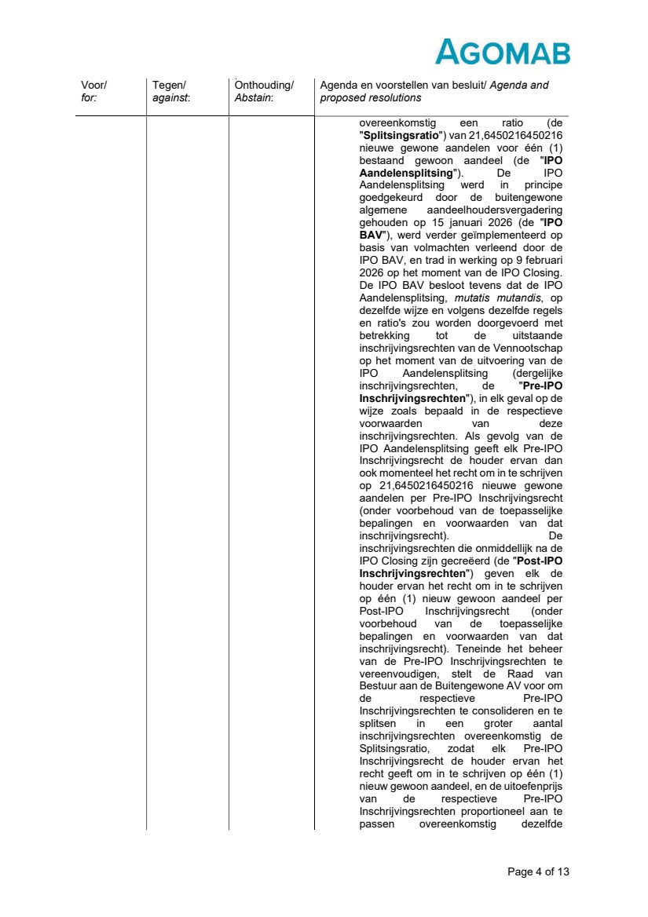 | Page 4 of 13 Voor/ for: Tegen/ against: Onthouding/ Abstain: Agenda en voorstellen van besluit/ Agenda and proposed resolutions overeenkomstig een ratio (de "Splitsingsratio") van 21,6450216450216 nieuwe gewone aandelen voor één (1) bestaand gewoon aandeel (de "IPO Aandelensplitsing"). De IPO Aandelensplitsing werd in principe goedgekeurd door de buitengewone algemene aandeelhoudersvergadering gehouden op 15 januari 2026 (de "IPO BAV"), werd verder geïmplementeerd op basis van volmachten verleend door de IPO BAV, en trad in werking op 9 februari 2026 op het moment van de IPO Closing. De IPO BAV besloot tevens dat de IPO Aandelensplitsing, mutatis mutandis, op dezelfde wijze en volgens dezelfde regels en ratio's zou worden doorgevoerd met betrekking tot de uitstaande inschrijvingsrechten van de Vennootschap op het moment van de uitvoering van de IPO Aandelensplitsing (dergelijke inschrijvingsrechten, de "Pre-IPO Inschrijvingsrechten"), in elk geval op de wijze zoals bepaald in de respectieve voorwaarden van deze inschrijvingsrechten. Als gevolg van de IPO Aandelensplitsing geeft elk Pre-IPO Inschrijvingsrecht de houder ervan dan ook momenteel het recht om in te schrijven op 21,6450216450216 nieuwe gewone aandelen per Pre-IPO Inschrijvingsrecht (onder voorbehoud van de toepasselijke bepalingen en voorwaarden van dat inschrijvingsrecht). De inschrijvingsrechten die onmiddellijk na de IPO Closing zijn gecreëerd (de "Post-IPO Inschrijvingsrechten") geven elk de houder ervan het recht om in te schrijven op één (1) nieuw gewoon aandeel per Post-IPO Inschrijvingsrecht (onder voorbehoud van de toepasselijke bepalingen en voorwaarden van dat inschrijvingsrecht). Teneinde het beheer van de Pre-IPO Inschrijvingsrechten te vereenvoudigen, stelt de Raad van Bestuur aan de Buitengewone AV voor om de respectieve Pre-IPO Inschrijvingsrechten te consolideren en te splitsen in een groter aantal inschrijvingsrechten overeenkomstig de Splitsingsratio, zodat elk Pre-IPO Inschrijvingsrecht de houder ervan het recht geeft om in te schrijven op één (1) nieuw gewoon aandeel, en de uitoefenprijs van de respectieve Pre-IPO Inschrijvingsrechten proportioneel aan te passen overeenkomstig dezelfde
 | 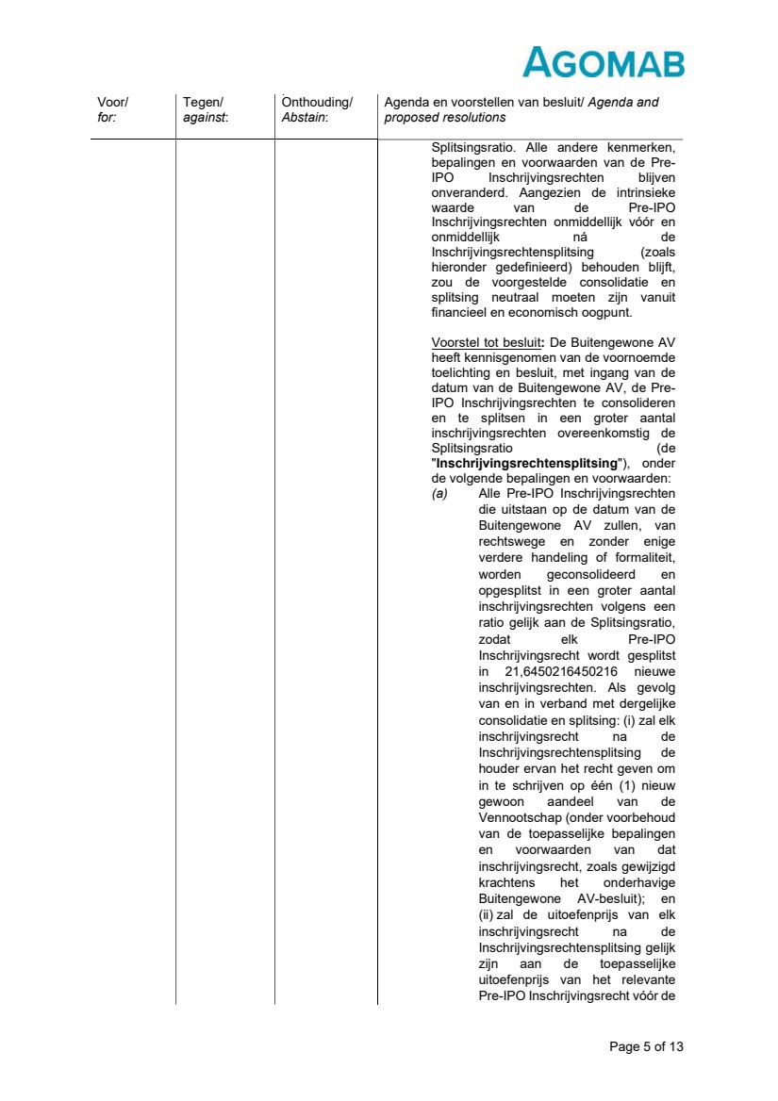 | Page 5 of 13 Voor/ for: Tegen/ against: Onthouding/ Abstain: Agenda en voorstellen van besluit/ Agenda and proposed resolutions Splitsingsratio. Alle andere kenmerken, bepalingen en voorwaarden van de Pre-IPO Inschrijvingsrechten blijven onveranderd. Aangezien de intrinsieke waarde van de Pre-IPO Inschrijvingsrechten onmiddellijk vóór en onmiddellijk ná de Inschrijvingsrechtensplitsing (zoals hieronder gedefinieerd) behouden blijft, zou de voorgestelde consolidatie en splitsing neutraal moeten zijn vanuit financieel en economisch oogpunt. Voorstel tot besluit: De Buitengewone AV heeft kennisgenomen van de voornoemde toelichting en besluit, met ingang van de datum van de Buitengewone AV, de Pre-IPO Inschrijvingsrechten te consolideren en te splitsen in een groter aantal inschrijvingsrechten overeenkomstig de Splitsingsratio (de "Inschrijvingsrechtensplitsing"), onder de volgende bepalingen en voorwaarden: (a) Alle Pre-IPO Inschrijvingsrechten die uitstaan op de datum van de Buitengewone AV zullen, van rechtswege en zonder enige verdere handeling of formaliteit, worden geconsolideerd en opgesplitst in een groter aantal inschrijvingsrechten volgens een ratio gelijk aan de Splitsingsratio, zodat elk Pre-IPO Inschrijvingsrecht wordt gesplitst in 21,6450216450216 nieuwe inschrijvingsrechten. Als gevolg van en in verband met dergelijke consolidatie en splitsing: (i) zal elk inschrijvingsrecht na de Inschrijvingsrechtensplitsing de houder ervan het recht geven om in te schrijven op één (1) nieuw gewoon aandeel van de Vennootschap (onder voorbehoud van de toepasselijke bepalingen en voorwaarden van dat inschrijvingsrecht, zoals gewijzigd krachtens het onderhavige Buitengewone AV-besluit); en (ii) zal de uitoefenprijs van elk inschrijvingsrecht na de Inschrijvingsrechtensplitsing gelijk zijn aan de toepasselijke uitoefenprijs van het relevante Pre-IPO Inschrijvingsrecht vóór de
 | 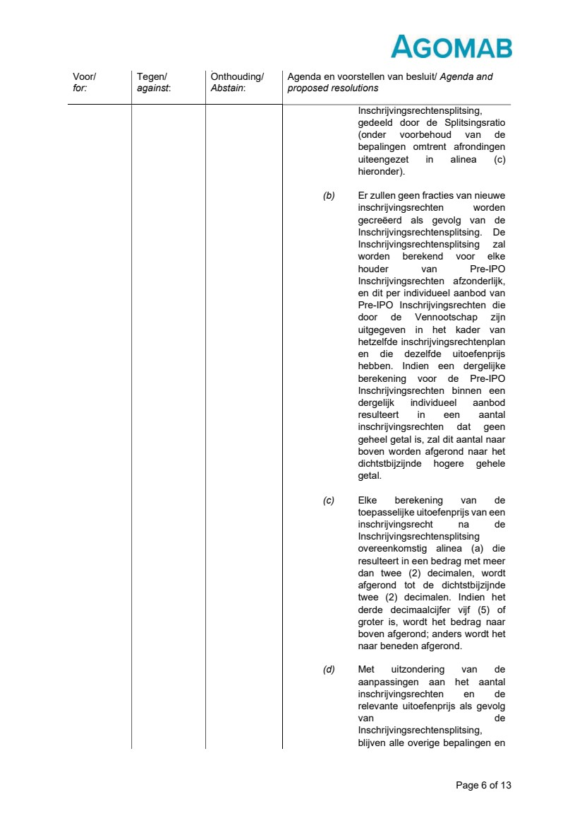 | Page 6 of 13 Voor/ for: Tegen/ against: Onthouding/ Abstain: Agenda en voorstellen van besluit/ Agenda and proposed resolutions Inschrijvingsrechtensplitsing, gedeeld door de Splitsingsratio (onder voorbehoud van de bepalingen omtrent afrondingen uiteengezet in alinea (c) hieronder). (b) Er zullen geen fracties van nieuwe inschrijvingsrechten worden gecreëerd als gevolg van de Inschrijvingsrechtensplitsing. De Inschrijvingsrechtensplitsing zal worden berekend voor elke houder van Pre-IPO Inschrijvingsrechten afzonderlijk, en dit per individueel aanbod van Pre-IPO Inschrijvingsrechten die door de Vennootschap zijn uitgegeven in het kader van hetzelfde inschrijvingsrechtenplan en die dezelfde uitoefenprijs hebben. Indien een dergelijke berekening voor de Pre-IPO Inschrijvingsrechten binnen een dergelijk individueel aanbod resulteert in een aantal inschrijvingsrechten dat geen geheel getal is, zal dit aantal naar boven worden afgerond naar het dichtstbijzijnde hogere gehele getal. (c) Elke berekening van de toepasselijke uitoefenprijs van een inschrijvingsrecht na de Inschrijvingsrechtensplitsing overeenkomstig alinea (a) die resulteert in een bedrag met meer dan twee (2) decimalen, wordt afgerond tot de dichtstbijzijnde twee (2) decimalen. Indien het derde decimaalcijfer vijf (5) of groter is, wordt het bedrag naar boven afgerond; anders wordt het naar beneden afgerond. (d) Met uitzondering van de aanpassingen aan het aantal inschrijvingsrechten en de relevante uitoefenprijs als gevolg van de Inschrijvingsrechtensplitsing, blijven alle overige bepalingen en
 | 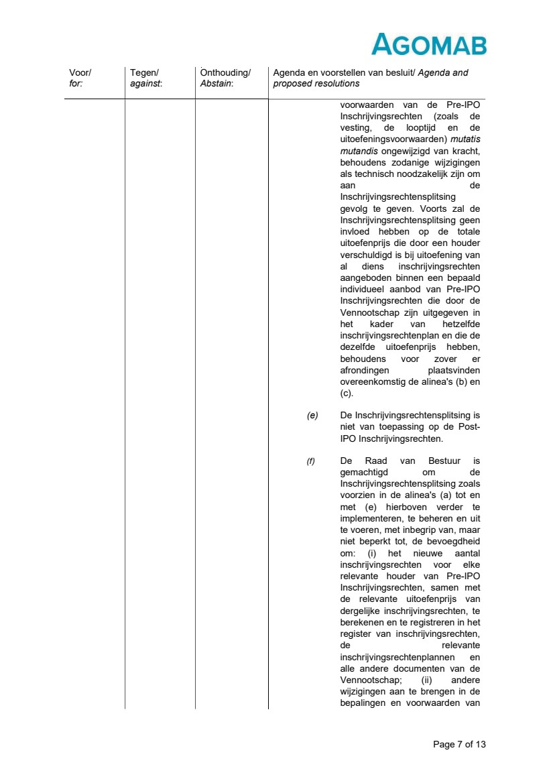 | Page 7 of 13 Voor/ for: Tegen/ against: Onthouding/ Abstain: Agenda en voorstellen van besluit/ Agenda and proposed resolutions voorwaarden van de Pre-IPO Inschrijvingsrechten (zoals de vesting, de looptijd en de uitoefeningsvoorwaarden) mutatis mutandis ongewijzigd van kracht, behoudens zodanige wijzigingen als technisch noodzakelijk zijn om aan de Inschrijvingsrechtensplitsing gevolg te geven. Voorts zal de Inschrijvingsrechtensplitsing geen invloed hebben op de totale uitoefenprijs die door een houder verschuldigd is bij uitoefening van al diens inschrijvingsrechten aangeboden binnen een bepaald individueel aanbod van Pre-IPO Inschrijvingsrechten die door de Vennootschap zijn uitgegeven in het kader van hetzelfde inschrijvingsrechtenplan en die de dezelfde uitoefenprijs hebben, behoudens voor zover er afrondingen plaatsvinden overeenkomstig de alinea's (b) en (c). (e) De Inschrijvingsrechtensplitsing is niet van toepassing op de Post-IPO Inschrijvingsrechten. (f) De Raad van Bestuur is gemachtigd om de Inschrijvingsrechtensplitsing zoals voorzien in de alinea's (a) tot en met (e) hierboven verder te implementeren, te beheren en uit te voeren, met inbegrip van, maar niet beperkt tot, de bevoegdheid om: (i) het nieuwe aantal inschrijvingsrechten voor elke relevante houder van Pre-IPO Inschrijvingsrechten, samen met de relevante uitoefenprijs van dergelijke inschrijvingsrechten, te berekenen en te registreren in het register van inschrijvingsrechten, de relevante inschrijvingsrechtenplannen en alle andere documenten van de Vennootschap; (ii) andere wijzigingen aan te brengen in de bepalingen en voorwaarden van
 | 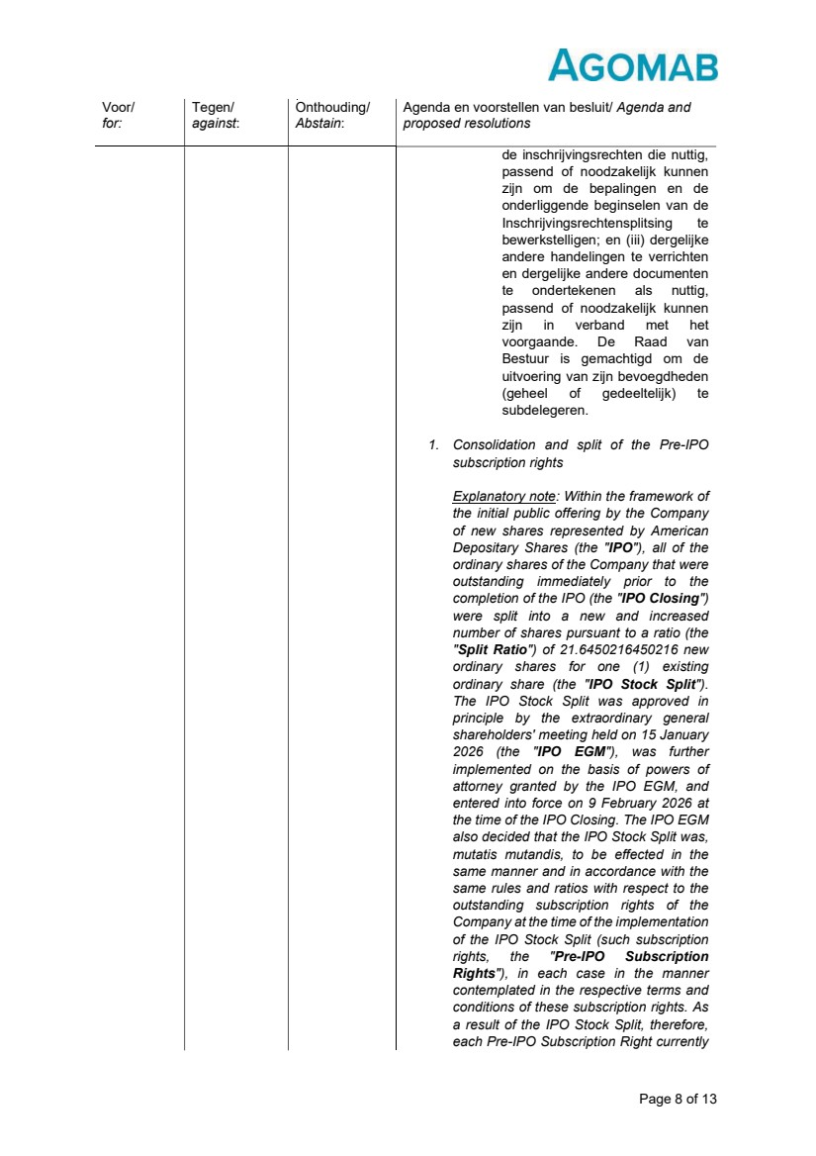 | Page 8 of 13 Voor/ for: Tegen/ against: Onthouding/ Abstain: Agenda en voorstellen van besluit/ Agenda and proposed resolutions de inschrijvingsrechten die nuttig, passend of noodzakelijk kunnen zijn om de bepalingen en de onderliggende beginselen van de Inschrijvingsrechtensplitsing te bewerkstelligen; en (iii) dergelijke andere handelingen te verrichten en dergelijke andere documenten te ondertekenen als nuttig, passend of noodzakelijk kunnen zijn in verband met het voorgaande. De Raad van Bestuur is gemachtigd om de uitvoering van zijn bevoegdheden (geheel of gedeeltelijk) te subdelegeren. 1. Consolidation and split of the Pre-IPO subscription rights Explanatory note: Within the framework of the initial public offering by the Company of new shares represented by American Depositary Shares (the "IPO"), all of the ordinary shares of the Company that were outstanding immediately prior to the completion of the IPO (the "IPO Closing") were split into a new and increased number of shares pursuant to a ratio (the "Split Ratio") of 21.6450216450216 new ordinary shares for one (1) existing ordinary share (the "IPO Stock Split"). The IPO Stock Split was approved in principle by the extraordinary general shareholders' meeting held on 15 January 2026 (the "IPO EGM"), was further implemented on the basis of powers of attorney granted by the IPO EGM, and entered into force on 9 February 2026 at the time of the IPO Closing. The IPO EGM also decided that the IPO Stock Split was, mutatis mutandis, to be effected in the same manner and in accordance with the same rules and ratios with respect to the outstanding subscription rights of the Company at the time of the implementation of the IPO Stock Split (such subscription rights, the "Pre-IPO Subscription Rights"), in each case in the manner contemplated in the respective terms and conditions of these subscription rights. As a result of the IPO Stock Split, therefore, each Pre-IPO Subscription Right currently
 | 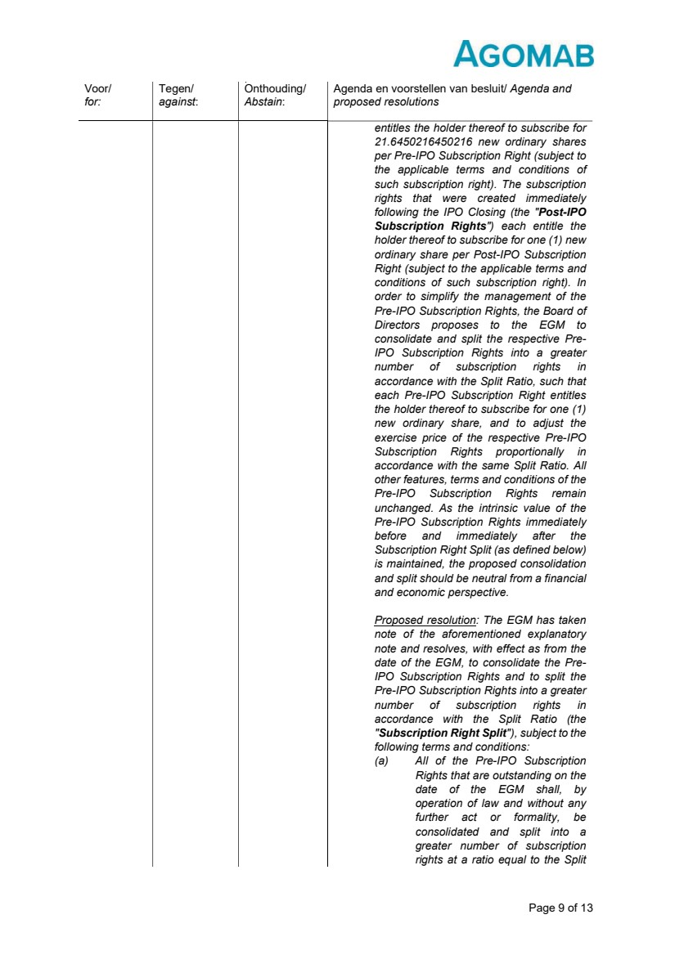 | Page 9 of 13 Voor/ for: Tegen/ against: Onthouding/ Abstain: Agenda en voorstellen van besluit/ Agenda and proposed resolutions entitles the holder thereof to subscribe for 21.6450216450216 new ordinary shares per Pre-IPO Subscription Right (subject to the applicable terms and conditions of such subscription right). The subscription rights that were created immediately following the IPO Closing (the "Post-IPO Subscription Rights") each entitle the holder thereof to subscribe for one (1) new ordinary share per Post-IPO Subscription Right (subject to the applicable terms and conditions of such subscription right). In order to simplify the management of the Pre-IPO Subscription Rights, the Board of Directors proposes to the EGM to consolidate and split the respective Pre-IPO Subscription Rights into a greater number of subscription rights in accordance with the Split Ratio, such that each Pre-IPO Subscription Right entitles the holder thereof to subscribe for one (1) new ordinary share, and to adjust the exercise price of the respective Pre-IPO Subscription Rights proportionally in accordance with the same Split Ratio. All other features, terms and conditions of the Pre-IPO Subscription Rights remain unchanged. As the intrinsic value of the Pre-IPO Subscription Rights immediately before and immediately after the Subscription Right Split (as defined below) is maintained, the proposed consolidation and split should be neutral from a financial and economic perspective. Proposed resolution: The EGM has taken note of the aforementioned explanatory note and resolves, with effect as from the date of the EGM, to consolidate the Pre-IPO Subscription Rights and to split the Pre-IPO Subscription Rights into a greater number of subscription rights in accordance with the Split Ratio (the "Subscription Right Split"), subject to the following terms and conditions: (a) All of the Pre-IPO Subscription Rights that are outstanding on the date of the EGM shall, by operation of law and without any further act or formality, be consolidated and split into a greater number of subscription rights at a ratio equal to the Split
 | 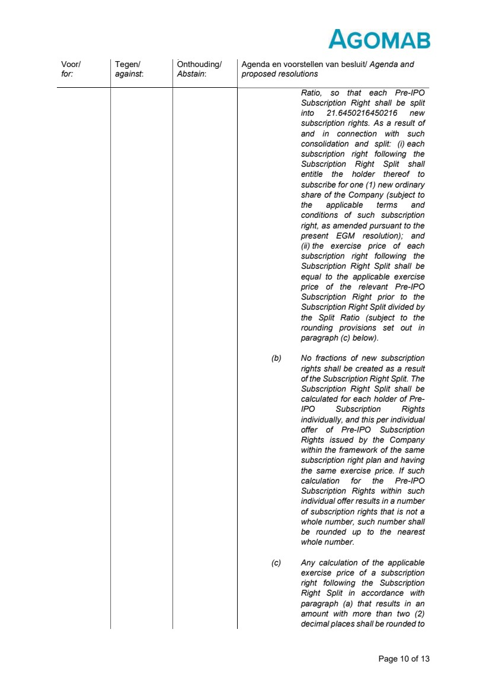 | Page 10 of 13 Voor/ for: Tegen/ against: Onthouding/ Abstain: Agenda en voorstellen van besluit/ Agenda and proposed resolutions Ratio, so that each Pre-IPO Subscription Right shall be split into 21.6450216450216 new subscription rights. As a result of and in connection with such consolidation and split: (i) each subscription right following the Subscription Right Split shall entitle the holder thereof to subscribe for one (1) new ordinary share of the Company (subject to the applicable terms and conditions of such subscription right, as amended pursuant to the present EGM resolution); and (ii) the exercise price of each subscription right following the Subscription Right Split shall be equal to the applicable exercise price of the relevant Pre-IPO Subscription Right prior to the Subscription Right Split divided by the Split Ratio (subject to the rounding provisions set out in paragraph (c) below). (b) No fractions of new subscription rights shall be created as a result of the Subscription Right Split. The Subscription Right Split shall be calculated for each holder of Pre-IPO Subscription Rights individually, and this per individual offer of Pre-IPO Subscription Rights issued by the Company within the framework of the same subscription right plan and having the same exercise price. If such calculation for the Pre-IPO Subscription Rights within such individual offer results in a number of subscription rights that is not a whole number, such number shall be rounded up to the nearest whole number. (c) Any calculation of the applicable exercise price of a subscription right following the Subscription Right Split in accordance with paragraph (a) that results in an amount with more than two (2) decimal places shall be rounded to
 | 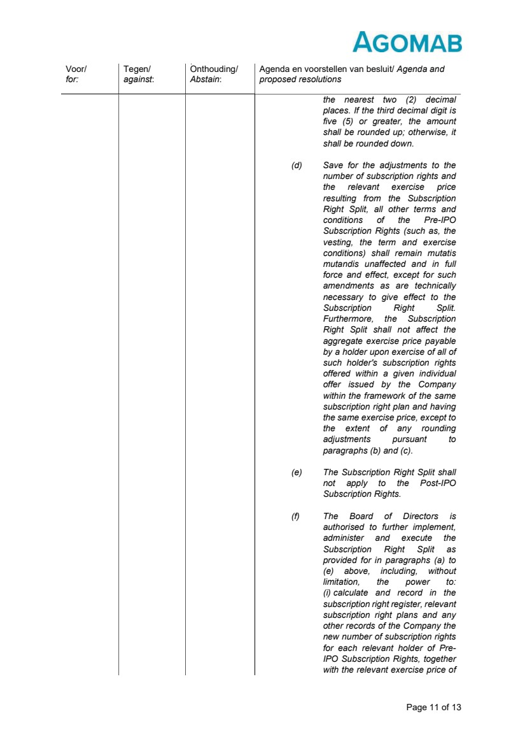 | Page 11 of 13 Voor/ for: Tegen/ against: Onthouding/ Abstain: Agenda en voorstellen van besluit/ Agenda and proposed resolutions the nearest two (2) decimal places. If the third decimal digit is five (5) or greater, the amount shall be rounded up; otherwise, it shall be rounded down. (d) Save for the adjustments to the number of subscription rights and the relevant exercise price resulting from the Subscription Right Split, all other terms and conditions of the Pre-IPO Subscription Rights (such as, the vesting, the term and exercise conditions) shall remain mutatis mutandis unaffected and in full force and effect, except for such amendments as are technically necessary to give effect to the Subscription Right Split. Furthermore, the Subscription Right Split shall not affect the aggregate exercise price payable by a holder upon exercise of all of such holder's subscription rights offered within a given individual offer issued by the Company within the framework of the same subscription right plan and having the same exercise price, except to the extent of any rounding adjustments pursuant to paragraphs (b) and (c). (e) The Subscription Right Split shall not apply to the Post-IPO Subscription Rights. (f) The Board of Directors is authorised to further implement, administer and execute the Subscription Right Split as provided for in paragraphs (a) to (e) above, including, without limitation, the power to: (i) calculate and record in the subscription right register, relevant subscription right plans and any other records of the Company the new number of subscription rights for each relevant holder of Pre-IPO Subscription Rights, together with the relevant exercise price of
 | 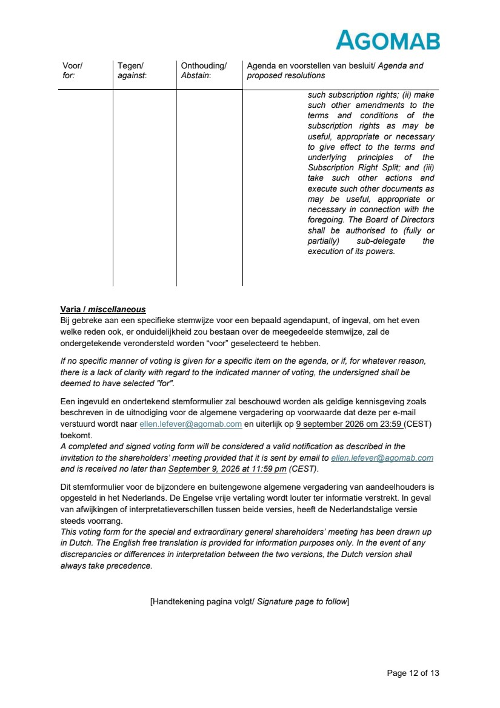 | Page 12 of 13 Varia / miscellaneous Bij gebreke aan een specifieke stemwijze voor een bepaald agendapunt, of ingeval, om het even welke reden ook, er onduidelijkheid zou bestaan over de meegedeelde stemwijze, zal de ondergetekende verondersteld worden “voor” geselecteerd te hebben. If no specific manner of voting is given for a specific item on the agenda, or if, for whatever reason, there is a lack of clarity with regard to the indicated manner of voting, the undersigned shall be deemed to have selected "for". Een ingevuld en ondertekend stemformulier zal beschouwd worden als geldige kennisgeving zoals beschreven in de uitnodiging voor de algemene vergadering op voorwaarde dat deze per e-mail verstuurd wordt naar ellen.lefever@agomab.com en uiterlijk op 9 september 2026 om 23:59 (CEST) toekomt. A completed and signed voting form will be considered a valid notification as described in the invitation to the shareholders’ meeting provided that it is sent by email to ellen.lefever@agomab.com and is received no later than September 9, 2026 at 11:59 pm (CEST). Dit stemformulier voor de bijzondere en buitengewone algemene vergadering van aandeelhouders is opgesteld in het Nederlands. De Engelse vrije vertaling wordt louter ter informatie verstrekt. In geval van afwijkingen of interpretatieverschillen tussen beide versies, heeft de Nederlandstalige versie steeds voorrang. This voting form for the special and extraordinary general shareholders’ meeting has been drawn up in Dutch. The English free translation is provided for information purposes only. In the event of any discrepancies or differences in interpretation between the two versions, the Dutch version shall always take precedence. [Handtekening pagina volgt/ Signature page to follow] Voor/ for: Tegen/ against: Onthouding/ Abstain: Agenda en voorstellen van besluit/ Agenda and proposed resolutions such subscription rights; (ii) make such other amendments to the terms and conditions of the subscription rights as may be useful, appropriate or necessary to give effect to the terms and underlying principles of the Subscription Right Split; and (iii) take such other actions and execute such other documents as may be useful, appropriate or necessary in connection with the foregoing. The Board of Directors shall be authorised to (fully or partially) sub-delegate the execution of its powers.
 |  | Page 13 of 13 Aldus getekend te/ signed at ________________________ op / on ___________________ Voor/ for ___________________ Naam/ Name: Titel/ Title:

