UNITED STATES

SECURITIES AND EXCHANGE COMMISSION

Washington, D.C. 20549

FORM 6-K

Report of Foreign Private Issuer

Pursuant to Rule 13a-16 or 15d-16 of

the Securities Exchange Act of 1934

For the month of April 2026

Commission File Number: 001-07291

AgomAb Therapeutics NV

Posthoflei 1/6

2600 Antwerpen

Belgium

Tel: +32 3 318 91 70

(Address, Including Zip Code, and Telephone Number,

Including Area Code, of Registrant’s Principal Executive Offices)

Indicate by check mark whether the registrant files or will file annual reports under cover of Form 20-F or Form 40-F.

Form 20-F ☒ Form 40-F ☐

Indicate by check mark if the registrant is submitting the Form 6-K in paper as permitted by Regulation S-T Rule 101(b)(1): ☐

Indicate by check mark if the registrant is submitting the Form 6-K in paper as permitted by Regulation S-T Rule 101(b)(7): ☐

On April 23, 2026, AgomAb Therapeutics NV (the “Company”) issued a press release titled, “Agomab Reports Full Year 2025 Financial Results and Confirms 2026 Outlook,” announcing the Company’s results for the year ended December 31, 2025 and providing a business update. A copy of this press release is furnished hereto as Exhibit 99.1.

On April 23, 2026, the Company also published on its website materials in connection with its Annual General Meeting to be held at 4:00 pm CEST on May 26, 2026. The information contained on, or that can be accessed through, the Company’s website is not incorporated by reference herein. The materials are attached hereto as Exhibits 99.2, 99.3, 99.4, and 99.5 are incorporated herein by reference.

The information contained in Exhibit 99.1 to this Form 6-K is intended to be furnished and shall not be deemed “filed” for purposes of Section 18 of the Securities Exchange Act of 1934, as amended (the “Exchange Act”), or otherwise subject to the liabilities of that section, nor shall it be deemed incorporated by reference in any filing under the Securities Act of 1933, as amended, or the Exchange Act, except as expressly set forth by specific reference in such filing. The information contained in this Form 6-K, including, Exhibits 99.2, 99.3, 99.4, and 99.5 are hereby incorporated by reference into the Company’s Registration Statement on Form S-8 (File No. 333-294220).

 |  |  | INDEX TO EXHIBITS
Number |  |  | Description
99.1 |  |  | Press Release of AgomAb Therapeutics NV dated April 23, 2026, announcing the Company’s results for the year ended December 31, 2025.
99.2 |  |  | Convening Notice for AgomAb Therapeutics NV’s Annual General Meeting to be held on May 26, 2026.
99.3 |  |  | Proxy Form for the Annual General Meeting to be held on May 26, 2026.
99.4 |  |  | Voting Instructions for the Annual General Meeting to be held on May 26, 2026.
99.5 |  |  | Annual Report to the Annual General Meeting to be held on May 26, 2026.

SIGNATURES

Pursuant to the requirements of the Securities Exchange Act of 1934, the registrant has duly caused this report to be signed on its behalf by the undersigned, thereunto duly authorized.

 | AgomAb Therapeutics NV
Date: April 24, 2026 | By: | /s/ Tim Knotnerus
 |  | Tim Knotnerus
 |  | Chief Executive Officer

Exhibit 99.1
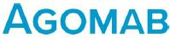

Agomab Reports Full Year 2025 Financial Results and Confirms 2026 Outlook

  - Cash and Cash Investments at December 31, 2025 of €116.5 Million and Gross Proceeds of $208 Million from Initial Public Offering (IPO) Expected to Extend Cash

Runway into First Half of 2029 --

    - Positive Interactions with U.S. Food and Drug Administration (FDA) on Design of Phase 2b Study with Ontunisertib in Fibrostenosing Crohn’s Disease (FSCD) --

  - On Track to Initiate Phase 2b Study in FSCD with Ontunisertib and Phase 2 Study in Idiopathic Pulmonary Fibrosis (IPF) with AGMB-447 in Second Half of 2026 --

- Topline Data from Open-Label Long-term Extension Study (OLE) Part of STENOVA Study with Ontunisertib in FSCD and from Phase 1b IPF Study Cohort with AGMB-

447 Expected in Second Half of 2026 --

Antwerp, Belgium, April 23, 2026 – Agomab Therapeutics NV (Nasdaq: AGMB) (“Agomab”), a clinical-stage biopharmaceutical company focused on fibro-inflammation, today reported financial results for the full year period ended December 31, 2025, and confirmed its outlook for 2026.

“2025 was a pivotal year for Agomab, with significant progress across our clinical programs and the positive topline results of the STENOVA Phase 2a study with ontunisertib in FSCD. Our momentum has continued into 2026 with positive Phase 1 results for AGMB-447 in healthy participants and the successful completion of our IPO,” said Tim Knotnerus, Chief Executive Officer of Agomab. “In the second half of this year, we expect the full read-out of the OLE study with ontunisertib in FSCD as well as the topline IPF cohort data of the Phase 1b study with AGMB-447. Based on the positive regulatory interactions on trial design, we are on track to start both the Phase 2b study with ontunisertib in FSCD and Phase 2 study with AGMB-447 in IPF later this year.”

Pierre Kemula, Chief Financial Officer of Agomab, added, “Thanks to the $208 million in gross proceeds raised from our IPO in February 2026, we are well-capitalized and we expect our cash reserves to last into the first half of 2029. With major milestones approaching later this year, we remain laser-focused on delivering on our corporate and clinical strategy.”

Recent Program Highlights and 2026 Anticipated Milestones

- Ontunisertib (AGMB-129), a gut-restricted small molecule inhibitor of ALK5 for the treatment of FSCD

o We continue to have positive interactions with the FDA to align on the study design of the Phase 2b study with ontunisertib in FSCD and are on track to initiate the study in the second half of 2026.

o We are progressing the OLE part of the STENOVA study (Part B) with ontunisertib in FSCD patients, with topline results expected in the second half of 2026. The 48-week data may provide important insights into extended treatment with ontunisertib in FSCD patients.

o As of February 2026, the Data Safety and Monitoring Board has not raised any safety issue and has recommended for the OLE study to continue as per the protocol with 200mg BID ontunisertib for up to 60 weeks.

  - The results of the 12-week placebo-controlled double-blind part of the STENOVA Phase 2a study with ontunisertib in FSCD (Part A) were presented as a late-breaker at the 21st Congress of ECCO (ECCO’26) in Stockholm, Sweden in February 2026. The late-breaking presentation was also featured by Nature Reviews Gastroenterology & Hepatology as one of the highlights of ECCO’26.

- AGMB-447, an inhaled small molecule inhibitor of ALK5 in development for the treatment of IPF

  - We continue to enroll participants in the IPF cohort of the Phase 1b study with AGMB-447. In this cohort, up to 12 participants with IPF will receive multiple doses of AGMB-447 or placebo over 14 days. We have dosed the first participants, and expect to report topline results in the second half of 2026.

  - We received positive scientific advice from the UK Medicines and Healthcare products Regulatory Agency (MHRA), supporting our planned Phase 2 trial in IPF patients. We are on track to initiate a Phase 2 proof-of-concept study with AGMB-447 in IPF in the second half of 2026.

  - We were granted a patent covering the composition of matter of AGMB-447 by the United States Patent and Trademark Office (USPTO), solidifying the foundational IP for AGMB-447 in the U.S.

Full Year 2025 Financial Results (consolidated)

- Cash Position: Cash, cash equivalents and short-term cash investments totaled €116.5 million as of December 31, 2025. Subsequently, in February 2026, we completed our IPO, in which we raised gross proceeds of approximately $208 million, including the proceeds from the underwriters’ partial exercise of their overallotment option, before deducting underwriting discounts and commissions and other offering expenses. We expect that our existing cash and cash investments, including the net proceeds from our IPO, will enable us to fund our operating expenses and capital expenditure requirements into the first half of 2029.

- R&D Expenses: Research and development (R&D) expenses were €48.9 million for the year ended December 31, 2025, as compared with €39.3 million for the year ended December 31, 2024. The increase in R&D expenses of €9.6 million for the year was primarily due to increased clinical trial expenses, which are outsourced activities, specifically for the two lead programs ontunisertib and AGMB-447.

- G&A Expenses: General and administrative (G&A) expenses were €12.8 million for the year ended December 31, 2025, as compared with €10.1 million for the year ended December 31, 2024. The increase of €2.7 million for the year mainly relates to increased employee benefits, reflecting organizational scaling to support company growth, including stock-based compensation.

- Net Loss: Net loss was €62.5 million for the full year ended December 31, 2025, compared to €46.3 million for the full year ended December 31, 2024.

Corporate

- The company has filed its Annual Report on Form 20-F with the U.S. Securities and Exchange Commission (SEC). The Annual Report is available on the Agomab website at https://agomab.com/ and on the SEC’s website at www.sec.gov.

- The company will hold its Annual General Meeting (AGM) at 4:00pm CEST on May 26, 2026. The convening notice for the AGM as well as all documents relevant for the meeting are available via the Agomab website at https://ir.agomab.com/governance/shareholder-meetings.

Financial performance
Consolidated statement of profit and loss
 |  |  | For the year ended December 31
(in thousands of €), except per share data |  |  | 2025 |  | 2024 |  |  | 2023
 | Research and development expenses |  | (48,877) |  | (39,310) |  |  | (26,311)
 | General and administrative expenses |  | (12,791) |  | (10,133) |  |  | (6,097)
 | Total operating expenses |  | (61,668 | ) | (49,443 | ) |  | (32,408 | )
 | Other operating income |  | 2,393 |  | 1,422 |  |  | 1,218
 | Operating loss |  | (59,275 | ) | (48,021 | ) |  | (31,190 | )
 | Changes in fair value of financial liabilities |  | (4,857) |  | 848 |  |  | 18,964
 | Financial expenses |  | (133) |  | (357) |  |  | (86)
 | Financial income |  | 1,718 |  | 1,267 |  |  | 303
 | Loss before taxes |  | (62,547 | ) | (46,263 | ) |  | (12,009 | )
 | Income tax (expense)/income |  | — |  | (4) |  |  | 619
 | Loss for the year |  | (62,547 | ) | (46,267 | ) |  | (11,390 | )
 |  |  |  |  |  |  |  | —
 | Weighted average number of common shares outstanding |  | 541,126 |  | 541,126 |  |  | 541,126
 | Basic and diluted loss per share (in €) |  | (143.22) |  | (107.09) |  |  | (35.63)
 |  |  | For the year ended December 31
(in thousands of €) |  |  | 2025 |  | 2024 |  |  | 2023
 | Loss for the year |  | (62,547 | ) | (46,267 | ) |  | (11,390 | )
 | Items that may be reclassified to profit or loss
 | Foreign currency translation differences |  | 21 |  | (10) |  |  | —
 | Items that will not be reclassified to profit or loss
 | Remeasurement of post-employment benefit obligations |  | (8) |  | (73) |  |  | —
 | Other comprehensive income or loss for the year, net of tax |  | 13 |  | (83 | ) |  | —
 | Total comprehensive income or loss for the year |  | (62,534 | ) | (46,350 | ) |  | (11,390 | )

Consolidated statement of financial position
 |  |  | For the year ended per
 |  |  | December 31
(In thousands of €) |  |  | 2025 |  |  | 2024
 | Assets
 | Non-current assets
 | Intangible assets |  | 20,110 |  |  | 20,110
 | Goodwill |  | 8,612 |  |  | 8,612
 | Property, plant and equipment |  | 503 |  |  | 619
 | Right-of-use assets |  | 1,083 |  |  | 1,373
 | Other financial assets |  | 11 |  |  | 12
 | Other non-current assets |  | 2,150 |  |  | 1,787
 | Total non-current assets |  | 32,469 |  |  | 32,513
 | Current assets
 | Other current assets |  | 4,723 |  |  | 2,386
 | Current financial investments |  | 30,096 |  |  | —
 | Cash and cash equivalents |  | 86,418 |  |  | 171,459
 | Total current assets |  | 121,237 |  |  | 173,845
 | Total assets |  | 153,706 |  |  | 206,358
 | Equity
 | Share capital |  | 223,072 |  |  | 223,072
 | Share premium reserve |  | 76,634 |  |  | 76,634
 | Retained earnings |  | (181,714) |  |  | (119,181)
 | Share-based payment reserves |  | 13,877 |  |  | 8,522
 | Other reserves |  | (967) |  |  | (966)
 | Equity attributable to the owners of the parent |  | 130,902 |  |  | 188,081
 | Total equity |  | 130,902 |  |  | 188,081
 | Liabilities
 | Non-current liabilities
 | Non-current lease liabilities |  | 1,005 |  |  | 1,272
 | Non-current contingent consideration |  | 3,210 |  |  | 7,879
 | Total non-current liabilities |  | 4,215 |  |  | 9,151
 | Current liabilities
 | Current lease liabilities |  | 249 |  |  | 273
 | Anti-dilutive warrants |  | — |  |  | —
 | Current contingent consideration |  | 6,526 |  |  | —
 | Trade and other payables |  | 10,266 |  |  | 8,052
 | Deferred income and accrued charges |  | 1,548 |  |  | 801
 | Total current liabilities |  | 18,589 |  |  | 9,126
 | Total liabilities |  | 22,804 |  |  | 18,277
 | Total equity and liabilities |  | 153,706 |  |  | 206,358

Consolidated statement of cash flows
 |  |  | For the years ended per
 |  |  |  |  | December 31
(In thousands of €) |  |  | 2025 |  | 2024 |  | 2023
 | Net loss for the year |  | (62,547 | ) | (46,267 | ) | (11,390 | )
 | Adjustments for non-cash items:
 | Current income tax expense (income) |  | — |  | 4 |  | 3
 | Deferred income tax expense (income) |  | — |  | — |  | (622)
 | Fair value (gain) loss on financial assets |  | (96) |  | — |  | —
 | Fair value (gain) loss on financial liabilities |  | 4,857 |  | (848) |  | (18,964)
 | Depreciation & amortization |  | 219 |  | 311 |  | 99
 | Share-based payment expenses |  | 5,355 |  | 1,071 |  | 2,159
 | Net foreign exchange losses (gains) |  | 57 |  | 231 |  | —
 | Interest expense |  | 69 |  | 77 |  | 86
 | Interest income |  | (1,614) |  | (1,218) |  | (303)
 | Operating cash flows before movements in working capital |  | (53,700) |  | (46,640) |  | (28,932)
 | movements in working capital:
 | Decrease/(increase) in other current assets |  | (2,337) |  | (315) |  | 1,343
 | Decrease/(increase) in other non-current assets |  | (363) |  | (342) |  | (331)
 | Increase/(decrease) in trade and other payables |  | 2,359 |  | (230) |  | 3,686
 | Increase/(decrease) in deferred income |  | 747 |  | (395) |  | (580)
 | Income taxes paid |  | — |  | (4) |  | (3)
 | Interest paid |  | (69) |  | (10) |  | (20)
 | Interest received |  | 1,622 |  | 1,106 |  | 245
 | Net cash flow from /(used in) operating activities |  | (51,741) |  | (46,828) |  | (24,592)
 | Purchases of property, plant and equipment |  | (4) |  | (675) |  | —
 | Purchase of financial investments |  | (30,000) |  | — |  | 40,000
 | Payment of contingent consideration from previous acquisition |  | (3,000) |  | — |  | —
 | Net cash flow from /(used in) investing activities |  | (33,004 | ) | (675 | ) | 40,000
 | Repayment of lease liabilities |  | (338) |  | (163) |  | (100)
 | Proceeds from capital increase |  | — |  | 97,055 |  | 79,871
 | Share issue costs |  | — |  | (129) |  | (453)
 | Other financial expense, net |  | — |  | — |  | 6
 | Net cash flow from /(used in) financing activities |  | (338 | ) | 96,762 |  | 79,324
 | Net increase/(decrease) in cash and cash equivalents |  | (85,083) |  | 49,260 |  | 94,732
 | Cash and cash equivalents at beginning of year |  | 171,459 |  | 122,402 |  | 27,670
 | Effect of foreign exchange rate changes |  | 45 |  | (204) |  | —
 | Cash and cash equivalents at end of year |  | 86,418 |  | 171,459 |  | 122,402

Ontunisertib and AGMB-447 are investigational drugs and not approved by any regulatory authority. Their efficacy and safety have not been established.

About Agomab

Agomab is a clinical-stage biopharmaceutical company focused on developing novel disease-modifying therapies for fibro-inflammatory diseases with high unmet medical need. Agomab’s product candidates are designed to target established potent pathways and utilize organ-restricted approaches, with the aim of increasing efficacy while minimizing safety liabilities. Fostering a culture of excellence, Agomab’s mission is to pioneer therapeutics that aim to resolve fibro-inflammation and restore organ function to enable people with these disorders to live fuller and healthier lives.

Cautionary Note Regarding Forward-Looking Statements

This press release includes certain disclosures that contain “forward-looking statements,” including, without limitation, statements regarding our expected cash runway, including that we anticipate our cash and cash investments and IPO proceeds will extend our runway into the first half of 2029, our focus on the discovery and development of our pipeline of novel product candidates for fibro-inflammatory disorders, the design of planned Phase 2 clinical trials with ontunisertib for FSCD and AGMB-447 for IPF, our expectation to initiate our Phase 2b Study of ontunisertib in FSCD and our Phase 2 study of AGMB-447 in IPF in the second half of 2026, as well as statements regarding future data readouts, including our expectation to release topline data from the OLE part of the STENOVA study and of the Phase 1b IPF Study Cohort with AGMB-447 in the second half of 2026. Forward-looking statements are based on Agomab’s current expectations and are subject to inherent uncertainties, risks and assumptions that are difficult to predict. Factors that could cause actual results to differ include, but are not limited to, risks and uncertainties related to the results of our clinical trials; expectations regarding the inherent uncertainties associated with the development of novel drug therapies; preclinical and clinical trial and product development activities and regulatory approval requirements for product candidates; the impact of governmental laws and regulations on our business; disruptions caused by our reliance on third party suppliers and service providers; the risk that our expectations and management’s guidance regarding our cash position and other financial estimates may be incorrect; and risks related to geopolitical conflicts and macro-economic events. These and other risks and uncertainties are described more fully in our filings and reports with the SEC, including in our most recent annual report on Form 20-F filed with the SEC and our subsequent filings and reports filed with the SEC. Forward-looking statements contained in this announcement are made as of this date, and Agomab undertakes no duty to update such information except as required under applicable law. Readers should not rely upon the information in this announcement as current or accurate after its publication date.

Contacts

Investors

Sofie Van Gijsel

VP of Investor Relations

E-Mail: sofie.vangijsel@agomab.com

Phone: +1 781 296 1143

Media

Gretchen Schweitzer

Trophic Communications

E-Mail: agomab@trophic.eu

Phone: +49 172 861 8540

Exhibit 99.2
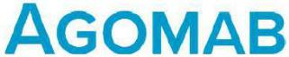

AGOMAB THERAPEUTICS NV

Posthoflei 1 box 6

2600 Antwerpen (Berchem)

Company number: 0674.527.310

RLE Antwerp, section Antwerp

(The “Company”)

Invitation to the annual general meeting on May 26, 2026

Dear all,

The Board of Directors of AgomAb Therapeutics NV is pleased to invite the holders of securities issued by the Company, the directors and the statutory auditor of the Company to the annual general meeting (the “general meeting”) of the Company.

The general meeting will take place on Tuesday May 26, 2026 at 4 pm (CEST) at the Company’s registered office at Posthoflei 1 box 6, 2600 Antwerp (Berchem), Belgium.

Agenda and proposed resolutions

Please find below the agenda to be discussed at the general meeting, including the proposed resolutions:

- For information purposes only, acknowledgement and discussion of the consolidated financial statements prepared (on a voluntary basis) in accordance with International Financial Reporting Standards, and additional related information and explanations, for the financial year ended December 31, 2025.
- Acknowledgement and discussion of the statutory financial statements, the report of the Board of Directors and the statutory auditor’s report for the financial year ended December 31, 2025.
- Approval of the statutory financial statements for the financial year ended December 31, 2025 and of the allocation of the result as proposed by the Board of Directors.

Proposed resolution: The general meeting resolves to approve the statutory financial statements for the financial year ended December 31, 2025 and of the allocation of the result as proposed by the Board of Directors.

- Discharge to the current and former members of the Board of Directors and the statutory auditor in respect of the performance of their respective duties during the financial year ending on December 31, 2025, as well as discharge for failing to hold the annual general meeting in the year 2025 on the date specified in the articles of association.

Proposed resolution: The general meeting grants discharge to each current and former director, including the former director Xiaoming Fang who resigned with effect from January 16, 2026, and the statutory auditor, for all liability arising from the exercise of their respective mandates during the financial year ended December 31, 2025. The general meeting also grants discharge to each current and former director for failing to hold the annual general meeting in the year 2025 on the date specified in the articles of association.

English free translation for information purposes only

- Reappointment of Mr. Ohad Hammer as a member of the Board of Directors.¹

Proposed resolution: As proposed by the Board of Directors and in accordance with the recommendation of the Company’s remuneration, nomination and corporate governance committee, the general meeting resolves to reappoint Mr. Ohad Hammer, who elects domicile at the Company’s registered office, as a director for a term of one year ending immediately after the annual general meeting to be held in 2027. Mr. Ohad Hammer’s mandate is remunerated. For the performance and duration of his mandate, Mr. Hammer is entitled to the annual remuneration as approved by the extraordinary general meeting of shareholders of the Company on January 15, 2026 and as determined in the notarial deed of February 9, 2026.

- Reappointment of Mr. Tim Knotnerus as a member of the Board of Directors.²

Proposed resolution: As proposed by the Board of Directors and in accordance with the recommendation of the Company’s remuneration, nomination and corporate governance committee, the general meeting resolves to reappoint Mr. Tim Knotnerus, who elects domicile at the Company’s registered office, as a director for a term of four years ending immediately after the annual general meeting to be held in 2030. Mr. Tim Knotnerus’ mandate as director is unpaid.

- Determination of statutory auditor’s fee.

Proposed resolution: As proposed by the Company’s audit committee, the general meeting resolves to approve, and insofar as necessary, ratify the increase of the statutory auditor’s fee to EUR 237,530 for the audit of the statutory financial statements and the consolidated financial statements for the financial year ended December 31, 2025 and the financial year ending on December 31, 2026. This amount is exclusive of various expenses, the IRE/IRB fee and VAT and is subject to indexation for financial year 2026.

No attendance quorum: There is no attendance quorum for the deliberation and voting on the agenda items referred to in the above agenda of the general meeting.

Voting and majority: Subject to applicable statutory provisions, each share shall carry one vote. In accordance with applicable law, the proposed resolutions referred to in the above agenda of the general meeting shall be adopted if they are approved by a simple majority of the valid votes cast by the shareholders. Pursuant to article 7:135 of the Companies and Associations Code of March 23, 2019 (as amended from time to time) (the “Companies and Associations Code”), holders of subscription rights may attend the general meeting, but only with an advisory vote.

Attendance at the general meeting:

In order to be admitted to the general meeting, holders of securities issued by the Company must comply with the formalities set out below, in accordance with article 22 of the Company’s articles of association juncto article 7:134 of the Companies and Associations Code.

The right to attend the general meeting and to exercise voting rights (where applicable) is determined on the basis of the registration of the relevant securities in the relevant register for those securities on Tuesday May 19, 2026 at 00:00 (CEST) (the “Record Date”), regardless of the number of shares held by the shareholder on the day of the general meeting. Only people who are shareholders or holders of subscription rights of the Company on the Record Date are entitled to attend the general meeting and to exercise voting rights (where applicable).

- For further information regarding Mr Hammer, please refer to his biography available on the Company’s website (https://agomab.com/about_us/#bod)

² For further information regarding Mr Knotnerus, please refer to his biography available on the Company’s website (https://agomab.com/about_us/#bod)

English free translation for information purposes only

In addition, shareholders must give written notice of their intention to attend the general meeting, stating the number of shares with which they wish to participate. This notice must be sent by email to ellen.lefever@agomab.com and must be received no later than Wednesday May 20, 2026 at 11:59 pm CEST (the “Notification Date”). A completed and signed proxy form or voting form (for shareholders only) will be deemed to constitute such notification provided that it is sent by email to ellen.lefever@agomab.com and is received no later than the Notification Date.

Natural persons who wish to attend the general meeting in person in their capacity as a shareholder, holder of subscription rights, proxy or representative of a legal entity must be able to prove their identity in order to gain access to the general meeting.

Representatives of legal entities or natural persons must also present documents proving that they are authorized to act as representatives.

Power of attorney

In accordance with article 23 of the articles of association, securityholders entitled to attend the general meeting may be represented by a proxy holder.

Shareholders wishing to make use of this possibility must return the attached power of attorney form, duly completed and signed, to the Company by email to ellen.lefever@agomab.com.

The power of attorney form must be received by the Company no later than the Notification Date.

Voting by letter

In accordance with article 27 of the articles of association, shareholders who are entitled to attend the general meeting may vote by letter using the enclosed voting form.

Shareholders wishing to make use of this possibility must return the attached voting form, duly completed and signed, to the Company by email to ellen.lefever@agomab.com.

The voting form must be received by the Company no later than the Notification Date.

Miscellaneous

Holders of American Depository Shares (“ADSs”) of the Company will receive the necessary information, documents and instructions relating to the general meeting, and the exercise of voting rights for the ordinary shares represented by these ADSs, from The Bank of New York Mellon, as depositary, or from the broker, bank or other nominee with whom they hold these ADSs.

Holders of securities are entitled to ask questions at the general meeting or in writing prior to the general meeting, to the Board of Directors regarding the agenda and to the statutory auditor regarding his report. Written questions must be sent to the Company by email to ellen.lefever@agomab.com. Written and oral questions will be answered during the relevant meeting in accordance with applicable law. Furthermore, in order for written questions to be considered, holders of securities issued by the Company who submitted the relevant written questions must meet the conditions for participating in the meeting, as described above.

This invitation to the general meeting has been drawn up in Dutch. The English free translation is provided for information purposes only. In the event of any discrepancies or differences in interpretation between the two versions, the Dutch version shall always take precedence.

English free translation for information purposes only

Availability of documents

In preparation for the general meeting, please consult the documents listed below, which are attached hereto and available on the Company’s website (https://ir.agomab.com/governance/shareholder-meetings).

- Consolidated financial statements prepared in accordance with International Financial Reporting Standards for the financial year ended December 31, 2025;

- The statutory financial statements for the financial year ended December 31, 2025;

- The statutory auditor’s report on the statutory financial statements for the financial year ended December 31, 2025;

- The report of the Board of Directors on the statutory financial statements for the financial year ended December 31, 2025;

- Proxy form;

- Voting form.

Prior to the general meeting, the Company’s holders of securities may also obtain a copy of the aforementioned documentation free of charge at the Company’s registered office (Posthoflei 1, Box 6, 2600 Antwerp (Berchem), Belgium).

Sincerely, on behalf of the Board of Directors

English free translation for information purposes only

Exhibit 99.3
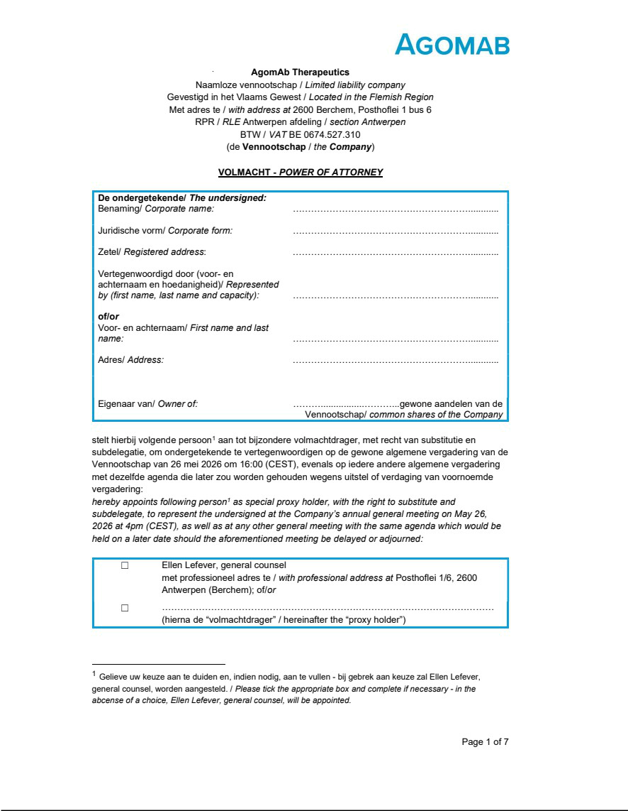

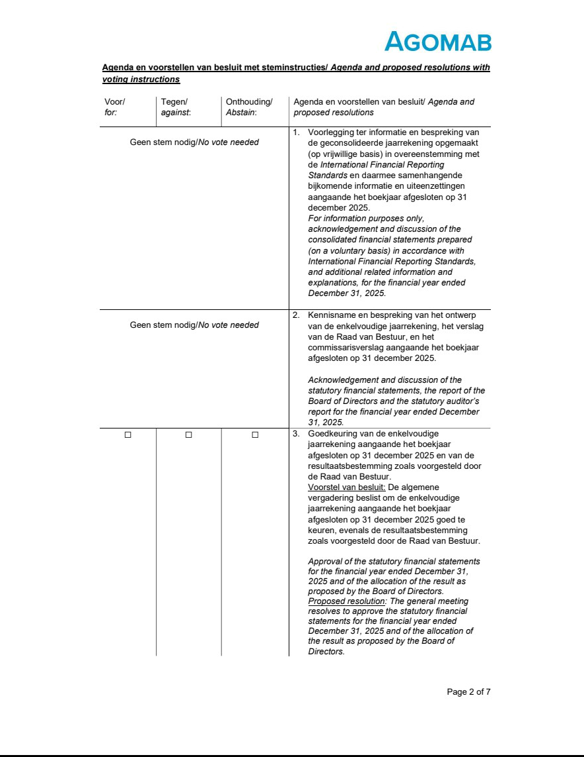

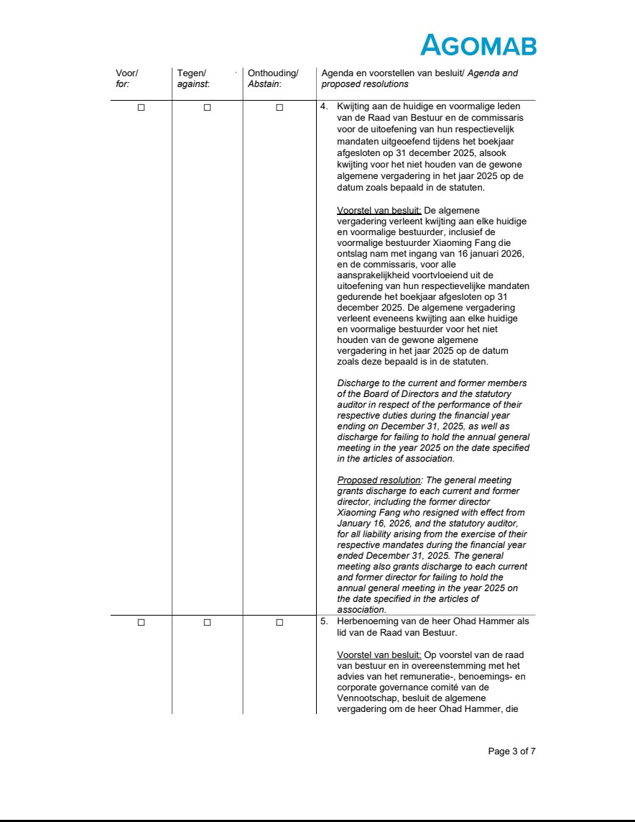

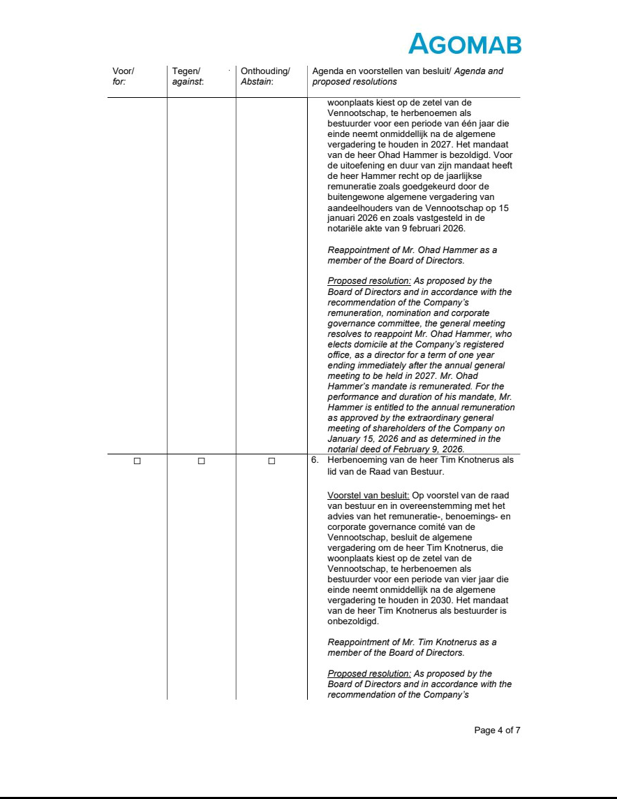

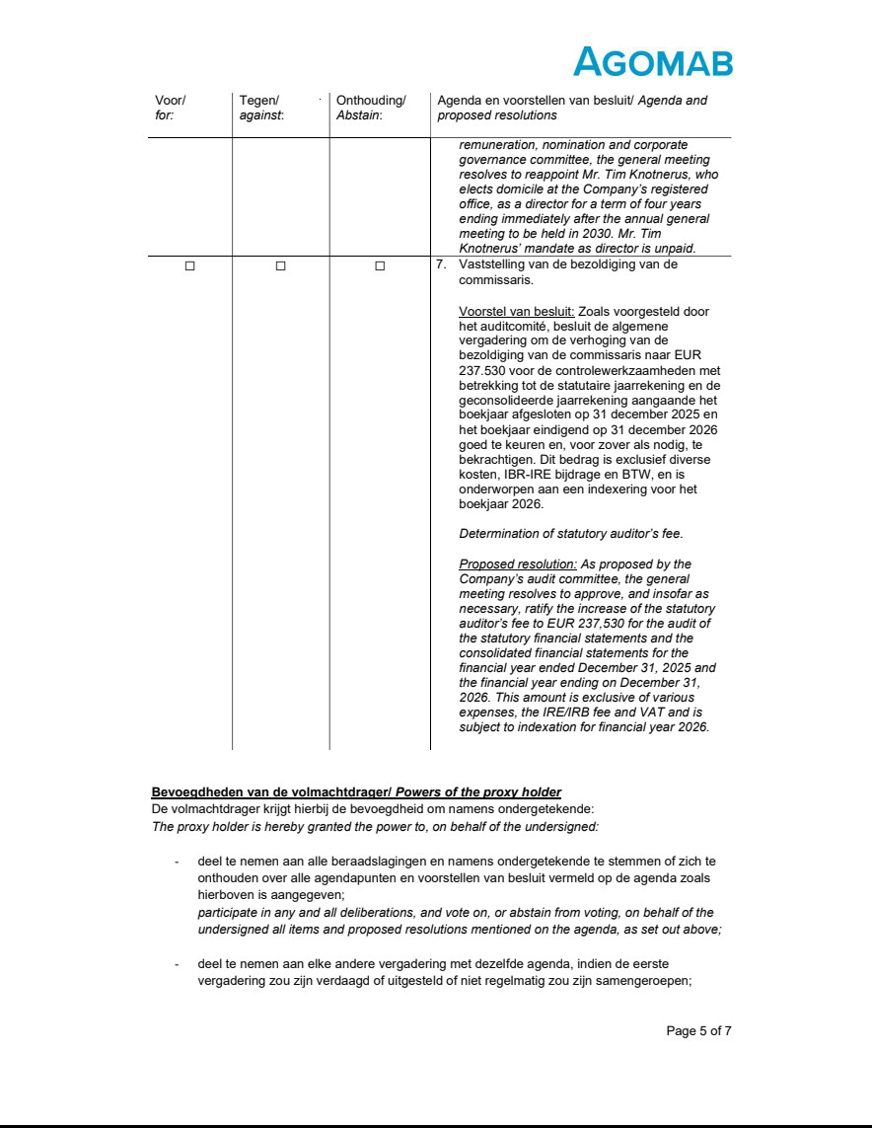

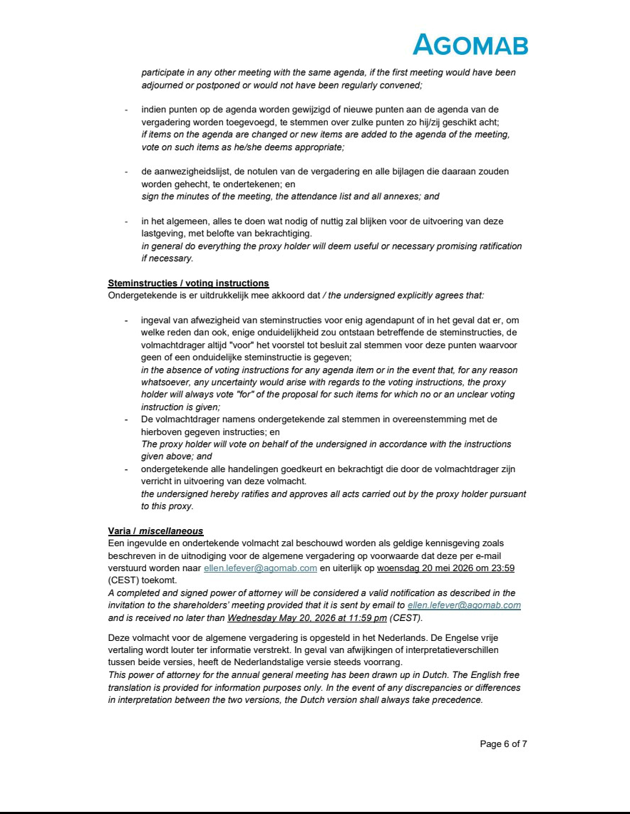

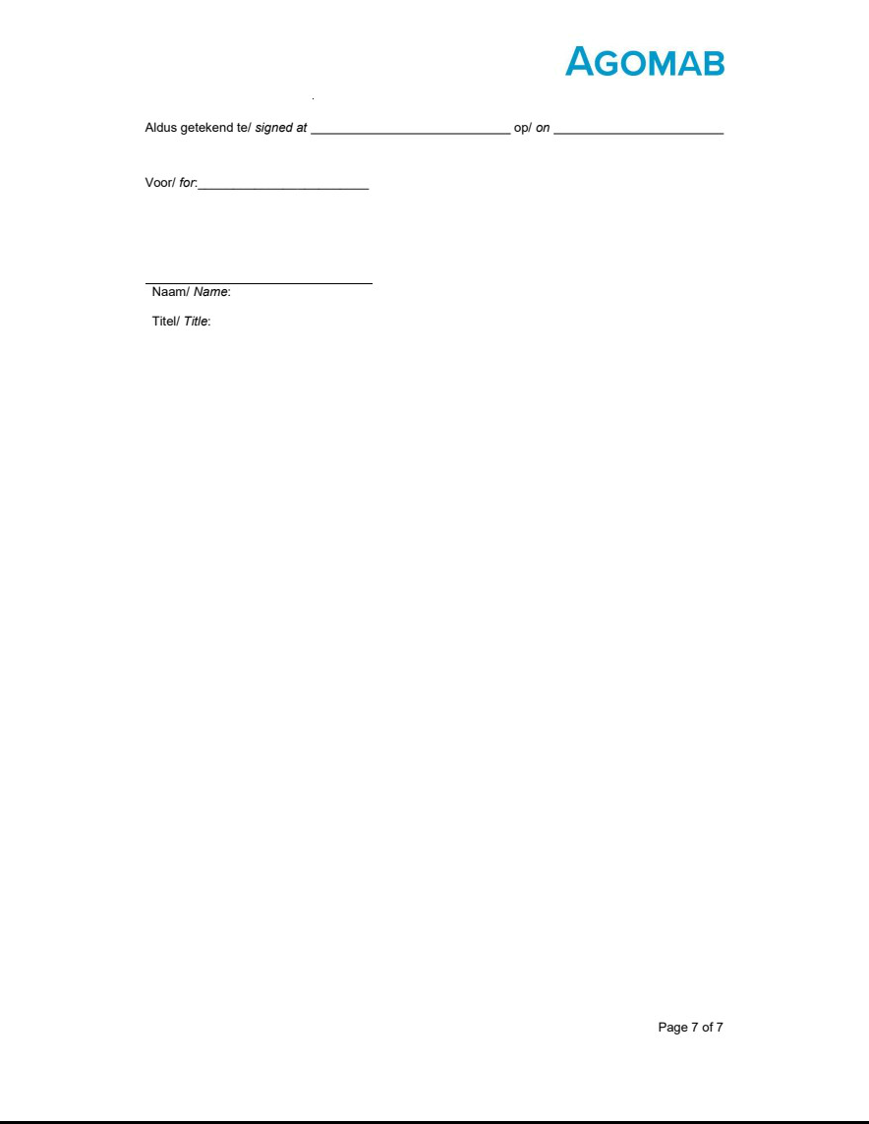

Exhibit 99.4
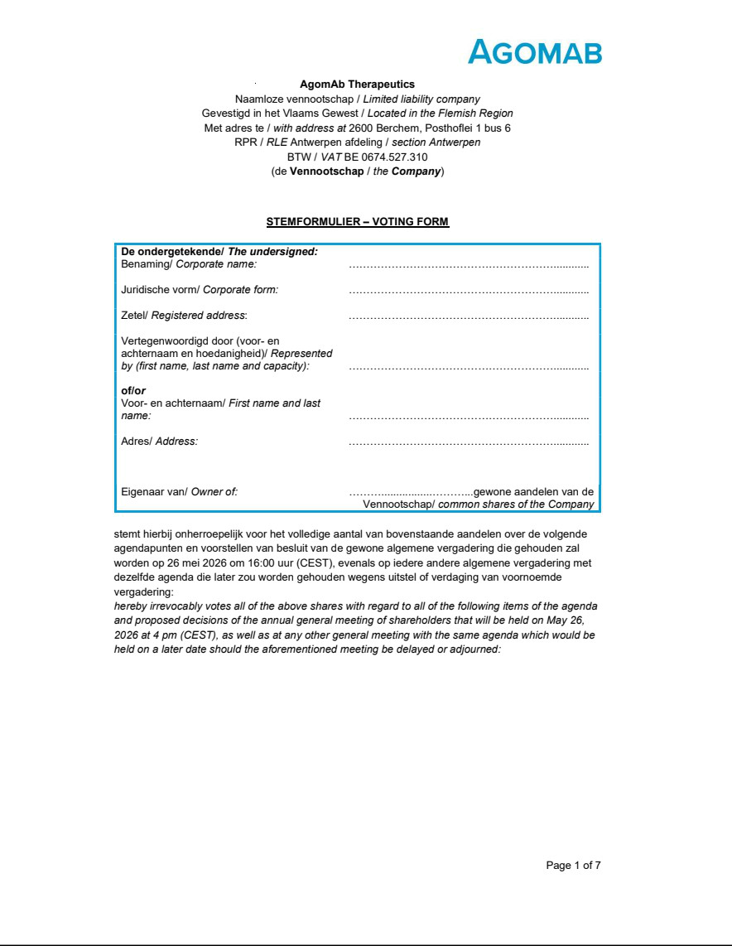

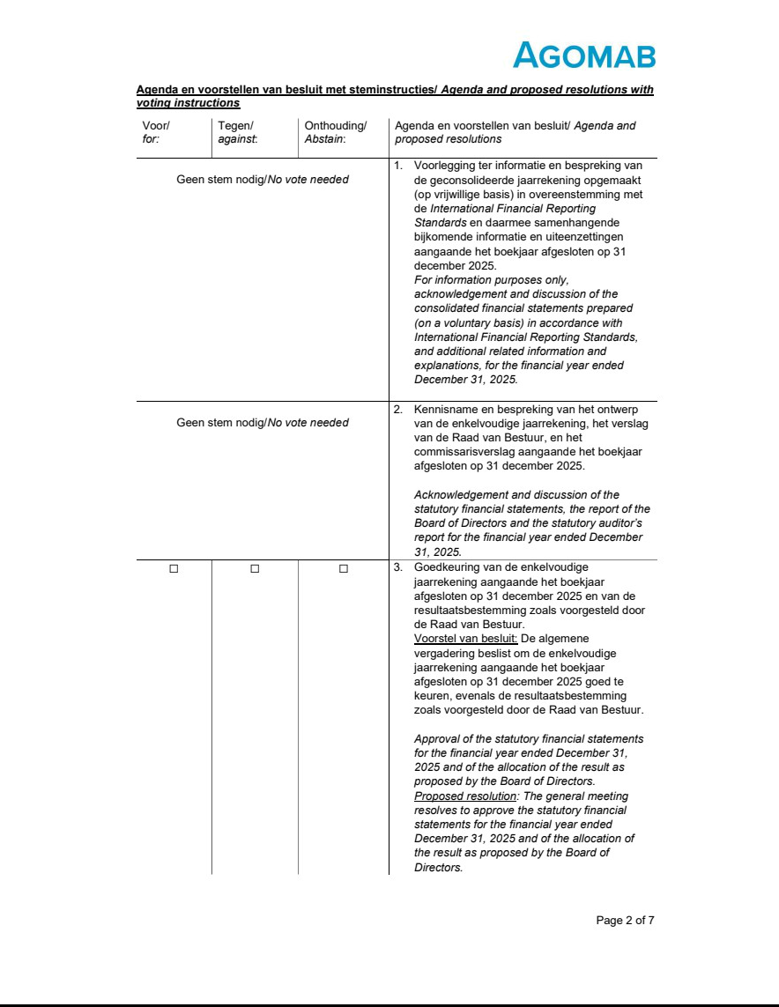

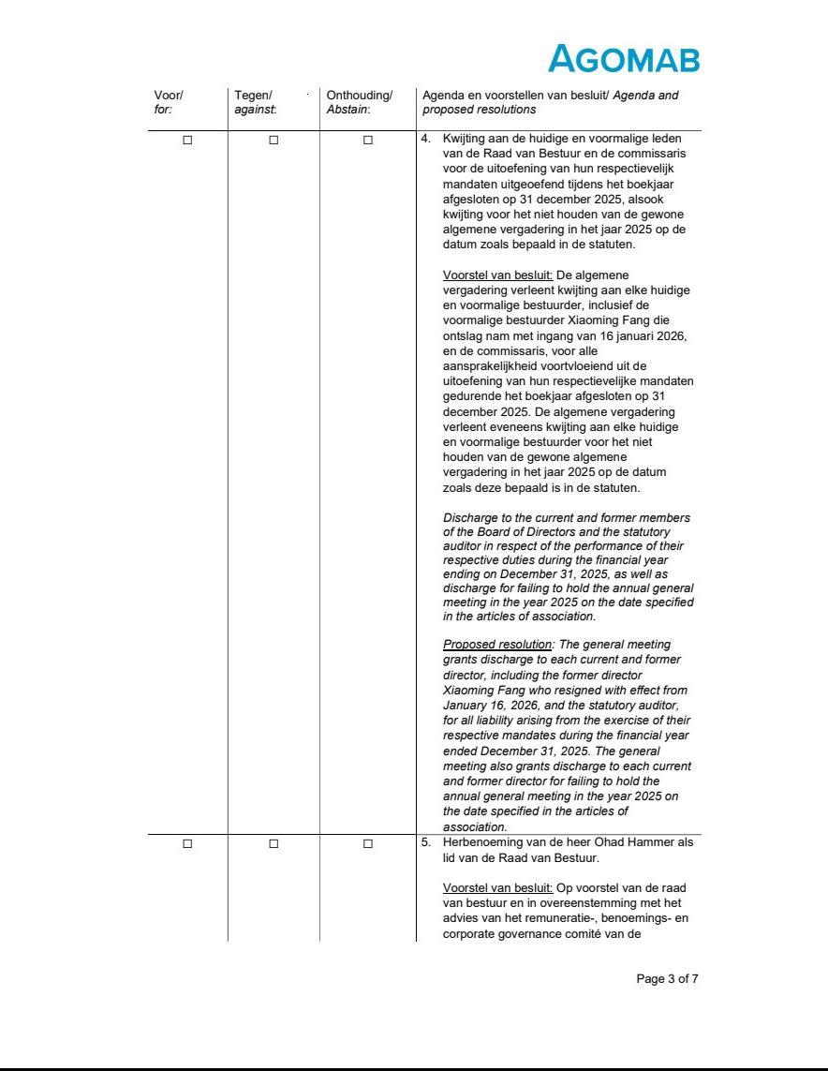

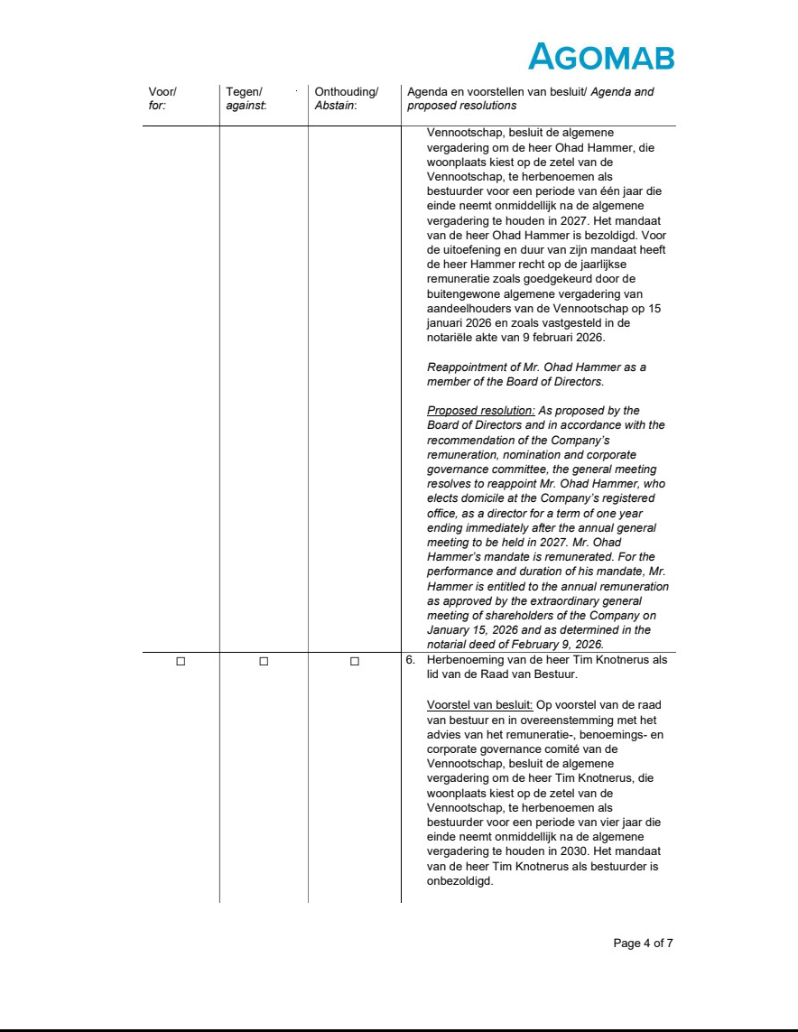

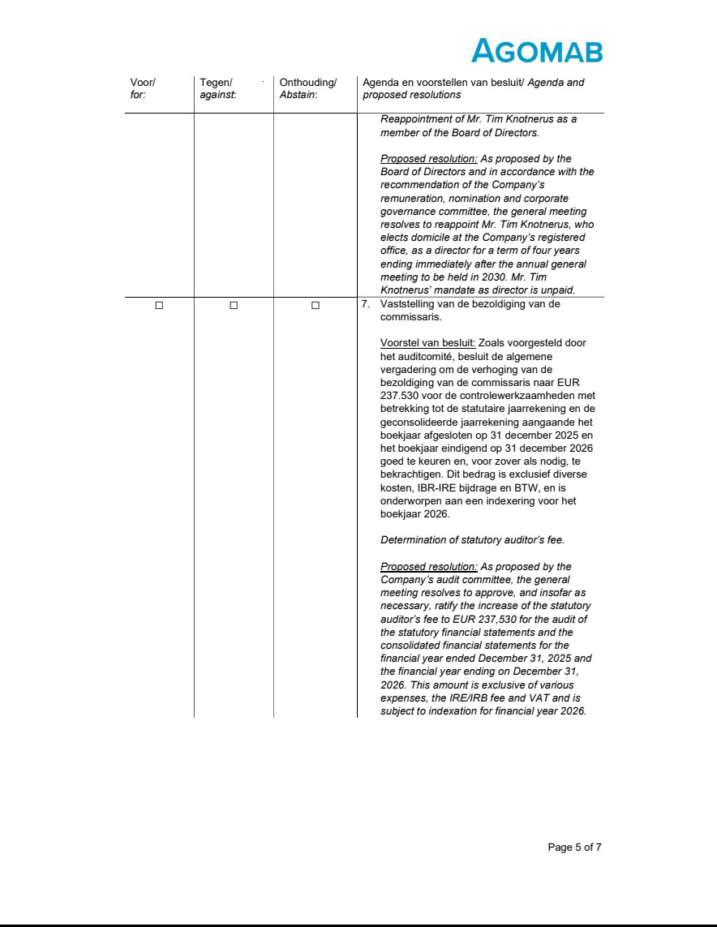

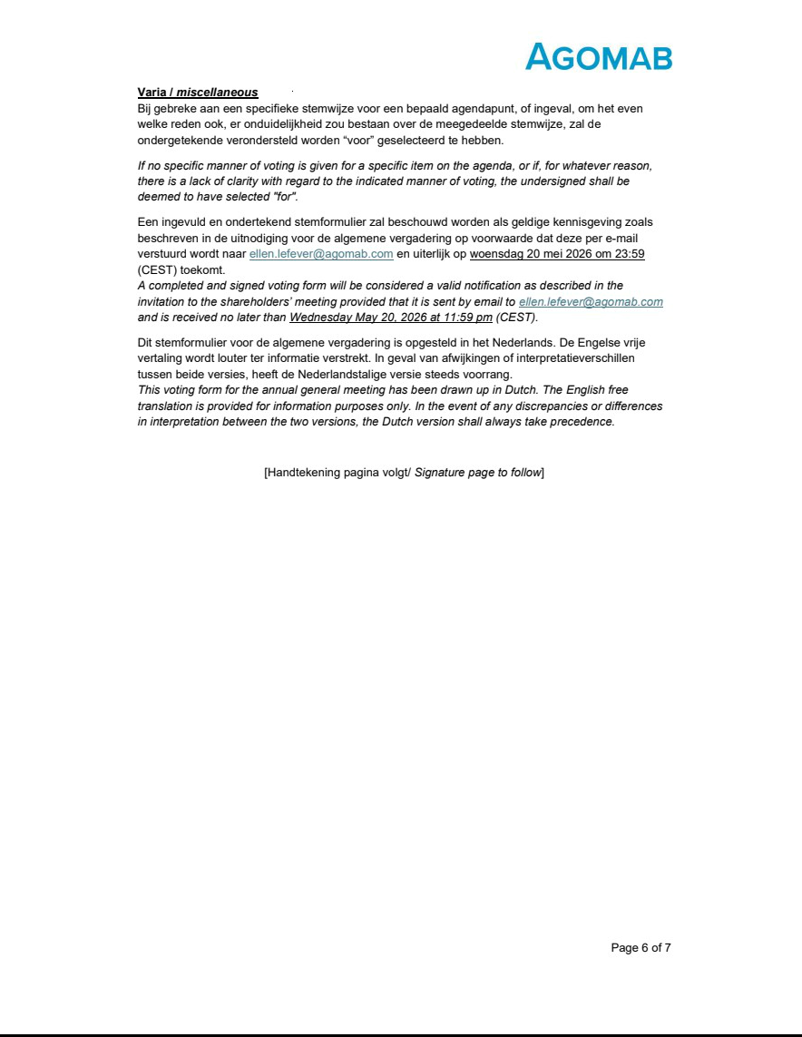

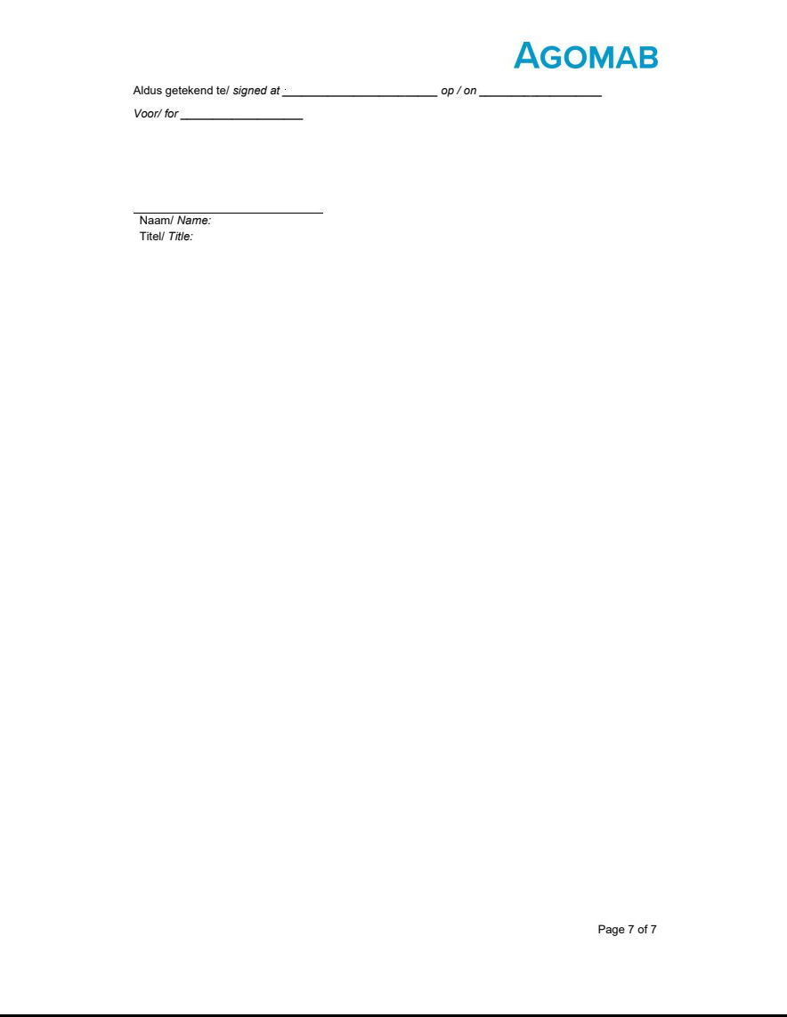

Exhibit 99.5

AGOMAB THERAPEUTICS NV

Posthoflei 1 box 6

2600 Antwerp (Berchem)

Company number: 0674.527.310

RLE Antwerp, section Antwerp

(the “Company”)

ANNUAL REPORT

TO THE ANNUAL GENERAL MEETING

TO BE HELD ON MAY 26, 2026

Dear all,

The Company’s Board of Directors is pleased to report to you, in accordance with statutory and articles of association provisions, on the Company’s activities for the financial year that began on January 1, 2025, and ended on December 31, 2025, and to present to you the statutory financial statements as of December 31, 2025. This report has been prepared in accordance with Articles 3:5 and 3:6 of the Belgian Code of Companies and Associations (the “BCCA”).

For additional information, the Board of Directors refers to the annual report filed with the U.S. Securities and Exchange Commission on Form 20-F.

- ANALYSIS OF COMPANY RESULTS

The Company’s results, as reflected in our statutory financial statements prepared in accordance with Belgian Generally Accepted Accounting Principles (Belgian GAAP), can be summarized as follows:

Balance sheet

Fixed assets amount to EUR 23,814,426, compared to EUR 20,932,238 in the previous financial year, primarily due to the increase in financial fixed assets from EUR 20,312,992 to EUR 23,311,390 due to the payment of an earn-out consideration of EUR 3,000,000 to the former shareholders of Agomab Spain, S.L.U. under the share purchase agreement, as amended from time to time.

Current assets amount to EUR 227,516,070 compared to EUR 237,730,025 in the previous financial year and consist primarily of intra-group receivables arising from current account balances with affiliated companies, term investments, and cash and cash equivalents held by the Company.

Due to the net loss of the financial year, the net equity decreased from EUR 253,687,197 in the previous financial year to EUR 244,064,213 for the financial year ended on December 31, 2025.

Debts amount to EUR 7,266,283, compared to EUR 4,975,067 in the previous financial year, and consist primarily of trade payables (EUR 3,567,997), taxes, salaries, and social security contributions (EUR 2,150,192), and accrued expenses (EUR 1,548,094).

The balance sheet total as of December 31, 2025, amounts to EUR 251,330,496, compared to EUR 258,662,264 in the previous financial year.

English free translation for information purposes only.

Profit and loss statement

Due to the nature of its activities and its current stage of development, the Company has no revenue. Other operating income amounted to EUR 20,309,676, compared to EUR 16,908,006 in the previous financial year. Operating expenses increased in the past financial year to EUR 34,506,071, compared to EUR 31,655,036 in the previous financial year. This increase is largely attributable to an increase in staff costs due to the growth of the Company.

Financial income for the financial year ended amounted to EUR 4,092,771, compared to EUR 2,556,280 in the previous financial year. Financial expenses amounted to EUR 33,068, compared to EUR 66,315 in the previous financial year. This resulted in a loss from business operations before taxes of EUR 10,136,692, compared to EUR 12,257,064 in the previous financial year and, after deduction of income taxes, a net loss for the financial year of EUR 9,622,983 compared to EUR 11,716,884 in the previous financial year. The loss to be allocated for the financial year amounts to EUR 9,622,983.

Allocation of results

The Board of Directors proposes the following allocation of the result:

Loss to be allocated for the financial year | (-) EUR 9,622,983
Loss carried forward from the previous financial year | (-) EUR 46,018,192
Loss to be allocated | (-) EUR 55,641,175
Loss to be carried forward | (-) EUR 55,641,175

- RISKS AND UNCERTAINTIES

The principal risks and uncertainties facing the Company are summarized below in a non-exhaustive manner. For a more detailed discussion, the Company refers to its annual report filed with the U.S. Securities and Exchange Commission on Form 20-F.

Risks related to our limited operating history, financial position and need for additional capital

- We are a clinical-stage biopharmaceutical company and have incurred significant losses since our inception. We expect to incur losses for the foreseeable future and may never achieve or maintain profitability.
- We will need to raise capital to finance our operations. Failure to obtain this necessary capital when needed, or on acceptable terms, may force us to delay, limit or terminate our product development efforts or other operations.
- We have never generated revenue from product sales.

- Our limited operating history may make it difficult for investors to evaluate the success of our business to date and to assess our future viability.

Risks related to the discovery and development of our product candidates

- Clinical development involves a lengthy, complex, and expensive process, with an uncertain outcome.

- We may incur additional costs or experience delays in completing, or ultimately be unable to complete, the development and commercialization of ontunisertib, AGMB-447, or any other product candidates.
- Due to our limited resources and access to capital, we must, and have in the past decided to, prioritize development of certain product candidates over other potential candidates. These decisions may prove to have been wrong and may adversely affect our revenues.

English free translation for information purposes only.

- If we encounter difficulties enrolling patients in our clinical trials, our clinical development activities could be delayed or otherwise adversely affected.

- Interim, topline and preliminary data from our preclinical studies and clinical trials that we announce or publish from time to time may change as more patient data becomes available and are subject to audit and verification procedures that could result in material changes in the final data.
- The results of preclinical studies and early-stage clinical trials of our product candidates may not be predictive of the results of later-stage clinical trials. Initial success in our ongoing clinical trials may not be indicative of results obtained when these trials are completed or in later stage trials.
- There is no established endpoint for Fibrostenosing Crohn’s Disease (FSCD) therapies, and the development and validation of efficacy endpoints to support approval may delay the development of our product candidates or increase development costs.
- We have conducted and may continue to conduct clinical trials for our product candidates outside of the U.S., and the FDA (US Food and Drug Administration) may not accept data from such trials, in which case our development plans may be delayed, which could materially harm our business.
- Our products and product candidates may have serious adverse, undesirable or unacceptable side effects, or even cause death, and we or others may identify undesirable or unacceptable side effects caused by any of our product candidates during clinical trials or after they have received marketing approval.
- The regulatory approval processes of the FDA and comparable foreign authorities are lengthy, time consuming and inherently unpredictable, and if we are ultimately unable to obtain regulatory approval for our product candidates, our business will be substantially harmed.
- We have obtained orphan drug designation for AGMB-447 and may seek orphan drug designation for a product candidate that we develop, and we may be unsuccessful; if we fail to obtain orphan drug designation or fail to obtain and/or maintain orphan drug exclusivity for our products or product candidates, our revenue may be reduced.
- If we decide to pursue accelerated approval for any of our product candidates, it may not lead to a faster development or regulatory review or approval process and does not increase the likelihood that our product candidates will receive marketing approval. If we are unable to obtain approval under an accelerated pathway, we may be required to conduct additional clinical trials beyond those that we contemplate, which could increase the expense of obtaining, reduce the likelihood of obtaining, and/or delay the timing of obtaining, necessary marketing approvals.
- We have obtained Fast Track Designation for ontunisertib and may seek Breakthrough Therapy Designation by the FDA or Priority Medicine, or PRIME, designation from the EMA (European Medicines Agency) for a product candidate that we develop, and we may be unsuccessful. If we are successful, the designation may not actually lead to a faster development or regulatory review or approval process.
- Even if we obtain approval from the FDA, the EMA or other applicable regulatory authorities for any product candidate that we may identify and pursue in the United States or Europe, we may never obtain approval to commercialize any such product candidates outside of those jurisdictions, which would limit our ability to realize their full market potential.

Risks related to commercialization

- The commercial success of our products and product candidates, including in new indications or methods of administration, will depend on the degree of market acceptance.
- Even if we receive regulatory approval of any of our product candidates, we will be subject to ongoing regulatory obligations and continued regulatory review, which may result in significant additional expense, and we may be subject to penalties if we fail to comply with regulatory requirements or experience unanticipated problems with our product candidates.
- If our target patient population is smaller than expected, we are unable to successfully enroll and retain patients in our clinical trials, or experience significant delays in doing so, we may not realize the full commercial potential of any product candidates.

English free translation for information purposes only.

- Our product candidates may face competition generally and sooner than expected.

- Even if we are able to commercialize any product candidate, such product candidate may become subject to unfavorable pricing regulations or third-party coverage and reimbursement policies, which could harm our business.
- Enacted and future healthcare reform legislation could impact demand for our product candidates, if approved, which could impact our business and future results of operations.
- If, in the future, we are unable to establish sales and marketing and patient support capabilities or enter into agreements with third parties to sell and market our current or future product candidates, we may not be successful in commercializing our current or future product candidates if and when they are approved, and we may not be able to generate any revenue.
- Changes in funding for, or other disruptions to the operations of, the FDA, U.S. Securities and Exchange Commission, or the SEC, and other government agencies, foreign or domestic, could hinder their ability to hire and retain key leadership and other personnel, prevent new products and services from being developed or commercialized in a timely manner or otherwise prevent those agencies from performing normal business functions on which the operation of our business may rely, which could negatively impact our business.
- We may encounter difficulties efficiently managing our growth and our increasing development, regulatory and sales and marketing capabilities, which could disrupt our operations.
- We have in the past and may in the future undertake strategic acquisitions and any difficulties from integrating such acquisitions could adversely affect the price of our American Depositary Shares (ADSs), operating results and results of operations.
- We are subject to healthcare laws, regulation and enforcement. The failure to comply with these laws could harm our results, operations and/or financial conditions.

- We may become exposed to costly and damaging liability claims.

Risk Factors Related to Other Government Regulations

- Failure to comply with anti-corruption laws and regulations, anti-money laundering laws and regulations, economic sanctions and/or export control regulations and other laws governing our operations such as in relation to sustainability could have an adverse impact on our business.
- We may become exposed to liability and substantial expenses in connection with environmental compliance or remediation activities.

- Significant political, trade, regulatory developments, and other circumstances beyond our control, could have a material adverse effect on our financial condition or results of operations.
- Healthcare legislative reform measures may have a material adverse effect on our business and results of operations.

Risks related to our reliance on third parties

- We rely, and intend to rely, on third parties to conduct our clinical trials and perform some of our research and preclinical studies. If these third parties do not satisfactorily carry out their contractual duties or fail to meet expected deadlines, our development programs may be delayed or subject to increased costs, each of which may have an adverse effect on our business and prospects.
- Our supply of product for our preclinical studies and clinical trials is dependent upon relationships with third-party manufacturers and suppliers.

- We intend to deliver AGMB-447 via a drug delivery device that will have its own regulatory, development, supply and other risks.

English free translation for information purposes only.

Risks related to our intellectual property

- Our commercial success depends on our ability to obtain, maintain, enforce, and otherwise protect our current and any future intellectual property and proprietary technology, and if the scope of the intellectual property protection obtained is not sufficiently broad, our competitors or other third parties could develop and commercialize products and product candidates similar or identical to ours and our ability to successfully develop and commercialize our product candidates may be adversely affected.

- It is difficult and costly to protect our intellectual property and our proprietary technologies, and we may not be able to ensure their protection.

- Patent terms may be inadequate to protect our competitive position on our products for an adequate amount of time.

- Changes in the interpretation of patent law in the United States and other jurisdictions could diminish the value of patents in general, thereby impairing our ability to protect our products.
- We may not be able to seek or obtain patent protection throughout the world or enforce such patent protection once obtained.

- In order to protect our competitive position around our product candidates, we may become involved in lawsuits to enforce our patents or other intellectual property, which could be expensive, time consuming and unsuccessful and which may result in our patents being found invalid or unenforceable.
- If we are sued for infringing intellectual property rights of third parties, such litigation could be costly and time consuming and could prevent or delay us from developing or commercializing our product candidates.
- Others may challenge inventorship or claim an ownership interest in our intellectual property which could expose it to litigation and have a significant adverse effect on its prospects.
- We may be subject to claims that we have wrongfully hired an employee from a competitor or by third parties asserting that our employees or we have misappropriated their intellectual property or claiming ownership of what we regard as our own intellectual property.
- We may rely on trade secrets and proprietary know-how which can be difficult to trace and enforce and, if we are unable to protect the confidentiality of our trade secrets, our business and competitive position would be harmed.
- We may need to acquire or license additional intellectual property from third parties, and such licenses may not be available or may not be available on commercially reasonable terms.
- If our trademarks and trade names are not adequately protected, then we may not be able to build name recognition in our trademarks of interest and our business may be adversely affected.
- Intellectual property rights do not necessarily address all potential threats to our business.

Risks related to data privacy

- We are subject to privacy laws, regulation and potential enforcement and contractual obligations related to data privacy and security. Our failure to comply with these laws, regulations and contractual obligations could lead to potential government enforcement actions and significant penalties against us, and harm our results, operations and/or financial conditions.
- The use of new and evolving technologies, such as artificial intelligence, in our business may result in spending material resources and presents risks and challenges that can impact our business including by posing security and other risks to our confidential and/or proprietary information, including personal information, and as a result we may be exposed to reputational harm and liability.

English free translation for information purposes only.

- Our internal computer systems, or those of our third-party collaborators or other contractors or consultants, may fail or suffer cybersecurity incidents or breaches, which could result in a material disruption of our current or future product candidates’ development programs, the disclosure of confidential or proprietary information, including personal data, damage our reputation, and subject us to significant financial and legal exposure.

Risks related to our operations, employee matters, and growth

- We will incur significant costs as a result of operating as a U.S. public company and our management will need to devote substantial time to U.S. public company compliance programs.
- If we fail to implement and maintain an effective system of internal control over financial reporting, we may not be able to accurately report our financial results, and our internal control over financial reporting may not prevent or detect all errors or acts of fraud. As a result, shareholders could lose confidence in our financial and other public reporting, which would harm our business and the trading price of the ADSs.
- Our future success depends on our ability to retain key executives and to attract, retain and motivate qualified personnel.

- We will need to develop and expand our company, and we may encounter difficulties in managing this development and expansion, which could disrupt our operations.
- Our employees, directors, principal investigators, clinical research organizations (CROs), contractors and consultants may engage in misconduct or other improper activities, including non-compliance with regulatory standards and requirements and insider trading.
- We may be forced to repay the technological innovation grants if we fail to comply with our contractual obligations under the applicable grant agreements.

Risks related to ownership of the ADSs

- We are an “emerging growth company” as defined in the US Jumpstart Our Business Startups Act of 2012, and we cannot be certain if the reduced disclosure requirements applicable to emerging growth companies will make the ADSs less attractive to investors.
- The market price of the ADSs may be volatile and fluctuate substantially (including due to different factors beyond our control), which could result in substantial losses for purchasers of the ADSs and may subject us to securities litigation suits.
- If we fail to establish and maintain proper internal controls, our ability to produce accurate financial statements or comply with applicable regulations could be impaired. As a result, shareholders could lose confidence in our financial and other public reporting, which would harm our business and the trading price of our ADSs.
- We may lose our foreign private issuer status, which would then require us to comply with the US Exchange Act’s domestic reporting regime and cause us to incur significant legal, accounting and other expenses.

Risks related to taxation

- Changes to applicable tax laws and regulations or exposure to additional tax liabilities could adversely affect our business and future profitability. English free translation for information purposes only.

General risk factors

  - Exchange rate fluctuations or abandonment of the euro currency may materially affect our results of operations and financial condition.

  - Unstable global economic or political conditions, inflation, increases in interest rates, natural disasters, public health crises, political crises, geopolitical events such as the crisis in Ukraine, the conflict between Iran and the US and Israel, the Israel-Hamas war, tensions in U.S.-China relations, or other macroeconomic conditions, could adversely affect our business, financial condition or results of operations.

- MATERIAL EVENTS SINCE THE END OF THE FINANCIAL YEAR

Since December 31, 2025, the following events have occurred that have had a material impact on the Company’s results and financial position:

  - The Company raised EUR 169,577,751.40 in gross proceeds through an initial public offering (the “IPO”) in the United States. In connection therewith, a capital increase was completed on February 9, 2026, whereby the Company issued 12,500,000 new shares. These new shares are represented by American Depositary Shares (“ADSs”), which are registered under the United States Securities Act of 1933 and listed on the Nasdaq Global Select Market. In the context of the IPO, the Company carried out a number of capital restructuring transactions, including a profit certificate conversion, a share conversion, and a stock split.

  - In the context of the IPO, the Company has issued an additional 482,967 new shares for a total issue price of EUR 6,658,169.91 on March 4, 2026. These new shares are represented by ADSs listed on the Nasdaq Global Select Market.

  - On February 9, 2026, and March 4, 2026, the Company issued a total of 2,933,873 new subscription rights to shares of the Company under a 2026 Global Stock Option Plan.

- CIRCUMSTANCES THAT MAY AFFECT THE COMPANY’S DEVELOPMENT

Apart from the risks and uncertainties described in section 2 and the material events since the end of the financial year described in section 3, there are no known circumstances that could significantly affect the Company’s development.

- RESEARCH AND DEVELOPMENT

The Company is a clinical-stage biopharmaceutical company focused on developing new therapies that can influence the course of fibro-inflammatory diseases. There is a significant unmet medical need in this area. Research and development is therefore at the core of the Company’s activities.

The Company is working on a series of innovative product candidates. The Group’s (as defined below) product pipeline includes:

Ontunisertib (also known as AGMB-129)

Ontunisertib is the Group’s lead product candidate. Ontunisertib is being developed for the treatment of fibrostenosing Crohn’s disease (FSCD), a subtype of Crohn’s disease in which scarring causes narrowing of the intestines.

The Group conducted a global, randomized, double-blinded, placebo-controlled phase 2a study with ontunisertib (“STENOVA study”). A total of 103 FSCD patients participated. In November 2025, the Company announced the key results of the STENOVA study. The primary endpoint of the study was met, namely assessing the safety and tolerability of ontunisertib in FSCD patients. The full results of the 48-week open-label extension of the STENOVA study are expected in the second half of 2026.

The Group plans to initiate a phase 2b study with ontunisertib in the second half of 2026.

English free translation for information purposes only.

AGMB-447

AGMB-447 is the Group’s second product candidate in clinical development. This product candidate is being developed for the treatment of idiopathic pulmonary fibrosis (“IPF”).

The Group is conducting a randomized, double-blinded, placebo-controlled phase 1 clinical trial. For this trial, 108 healthy subjects were recruited for the Single Ascending Dose (SAD) and Multiple Ascending Dose (MAD) B1-B6 components. The Group has announced positive topline interim results for these parts of the trial.

In addition, the Group has initiated the IPF cohort of the phase 1b study, in which the first patients have been recruited. Up to 12 IPF patients may participate in this cohort.

The results are expected to be published in the second half of 2026.

The Group plans to initiate a phase 2 study with IPF patients in the second half of 2026.

Development and Preclinical Portfolio

The Company has various research and development programs at different stages of development.

AGMB-101 is the Company’s most advanced preclinical product candidate.

The Company has received VLAIO grants to support its research and development programs.

- BRANCHES OF THE COMPANY

As of December 31, 2025, the Company had the following subsidiaries (collectively, the “Group”):

Name |  | Address
Agomab Spain, S.L.U. |  | Parque Empresasarial de Touro, parcelas 26-27
 |  | 15822 Fonte Diaz Touro
 |  | Spain
Agomab US, Inc. |  | 1 Broadway
 |  | MA 02142 Cambridge
 |  | United States

The Company does not have any branches.

- JUSTIFICATION OF THE APPLICATION OF VALUATION PRINCIPLES UNDER THE GOING CONCERN ASSUMPTION

The balance sheets for the financial years from January 1, 2024, to December 31, 2024, and from January 1, 2025, to December 31, 2025, show that the Company has carried forward a loss for several consecutive years.

A cash flow forecast was prepared for the Company for the next twelve months, as well as a consolidated cash flow forecast. This cash flow is based on a budget and action plan in which management has made a realistic assessment of the Group’s future EBITDA, cash flows, and other sources of financing. Based on the cash flow plan, strict expenditure management and the additional capital increase in February 2026 (see section 3), it appears that the Company’s and the Group’s financing needs can be met for the next twelve months. Based on this, the Company expects to be able to meet its obligations for the next twelve months. In view of the foregoing and the above assumptions, the Board of Directors therefore proposes that the financial statements be prepared on a going concern basis.

English free translation for information purposes only.

- CONFLICTS OF INTEREST IN THE BOARD OF DIRECTORS

The following conflicts of interest of a financial nature, as defined in Article 7:96 of the BCCA, arose during the financial year (free translations of the relevant portions of the minutes and/or resolutions, where applicable):

  - In its meeting of 5 February 2025, the Board of Directors decided, on the recommendation of the Remuneration and Nomination Committee, to approve the grant of a bonus to Mr. Tim Knotnerus and to increase his target bonus from 40% to 45% of his annual base salary, starting from financial year 2025 onwards. With respect to the decisions to award Tim Knotnerus a bonus equal to 48% of his annual salary for the performance of his duties during financial year 2024 and to increase his target bonus to 45% of his annual salary with effect as of financial year 2025, the Board acknowledged the potential conflict of interest of a financial nature in accordance with Article 7:96 of the Belgian Code of Companies and Associations. The 2024 bonus and target bonus increase were granted on the recommendation of the remuneration committee, constitute a justified reward for the performance of Mr. Knotnerus and are intended to motivate and retain the beneficiary. The 2024 bonus and target bonus increase will not have a material impact on the financial position of the Company. The Board’s approval was granted unanimously by all Directors except Mr. Knotnerus who did not participate in the decision-making with respect to his 2024 bonus and target bonus increase, in accordance with the conflict of interest procedure of Article 7:96 of the Belgian Code of Companies and Associations.

  - In its meeting of 3 October 2025, the Board of Directors, on the recommendation of the Remuneration and Nomination Committee, approved the offer of 9,509 new 2024 (B) Employee Stock Option Warrants to Mr. Tim Knotnerus with an exercise price of EUR 0.01 per ESOP. With respect to this decision, the Board acknowledges the potential conflict of interest of a financial nature in accordance with article 7:96 BCCA. The offer of 2024 (B) Employee Stock Option Warrants is made on the recommendation of the Company’s remuneration committee. It is intended to motivate and retain the beneficiary and to keep his interests aligned with those of the Company’s shareholders. This offer will not have a material impact on the financial position of the Company. The Board’s approval was granted unanimously by all Directors except Mr. Knotnerus who did not participate in the decision-making with respect to his ESOP offer, in accordance with the conflict of interest procedure of Article 7:96 of the Belgian Code of Companies and Associations.

  - On 17 November 2025, the Board of Directors decided to approve the offer of respectively 10,039, 1,255 and 1,255 new 2024 (B) Employee Stock Option Warrants to Mr. David Epstein, Ms. Angelika Jahreis, and Mr. Colin Bond, members of the board of directors. With respect to this decision, the board acknowledges the potential conflict of interest of a financial nature in accordance with article 7:96 BCCA. The offer of 2024 (B) Employee Stock Option Warrants is made on the recommendation of the Company’s remuneration committee. It is intended to motivate and retain the beneficiaries and to keep their interests aligned with those of the Company’s shareholders. This offer will not have a material impact on the financial position of the Company. The Board’s approval is granted unanimously by all Directors except Mr. Epstein, Ms. Jahreis, and Mr. Bond who sign these written resolutions for acknowledgement only with respect to this decision to offer them 2024 (B) Employee Stock Option Warrants, in accordance with the conflict of interest procedure of article 7:96 BCCA.

- FINANCIAL INSTRUMENTS

The Company does not hold any financial instruments as per 31 December 2025.

- ACQUISITION OR DISPOSAL OF TREASURY SHARES

Not applicable.

[Signature page to follow]

English free translation for information purposes only.

Done in Berchem on 23 April 2026

Name:

Title:

Name:

Title:

English free translation for information purposes only.

